2020
Kennedy High School
Cougar Electric Car Company
v
9
8
4
Advisor: Barry Wilson
Crew Chief: Jakob Davis
Assistant Crew Chief: Mathew Morrow
Driver: Kaleigh Martin
Battery Lead: Noah Wilson
Documentation: Elizabeth Severson
and Kaleigh Martin

2021
Table of Contents
Introduction: Our Program and It’s History 1
Contact Information 2
Electric Car at Kennedy 2
Skills 2
2020-2021 Racing Season 2
Introduction: The 983 Car and the Team 4
A Brief Overview of a Hectic Season 5
Car History 5
Teams 5
Mechanical Engineering 6
Electrical Engineering 6
Promotions 6
Drivers 6
984 Travel Team Member Biographies 5
984 Non-Traveling Team Member Biographies 5
Design: Process and Notes 4
Research Notes 5
Sketches 5
Preliminary 6
Driver Compartment 6
Tail 6
Aerodynamics 5
Center of Balance 5
Center of Gravity 5
Construction: Process and Timelines 4
Electrical Engineering 4
Field Testing 4
Fundraising: Sponsors and Events 4

DELETE LATER
Error caught in 984/985 that might not be in 983
Add Center Calculations for Derek
Update Table of Contents
Page numbers
Page headers/footers
Axel
Other car #s used inappropriately\

Stuff I want to add…..
Wiring Diagrams????
Flesh out car parts section with pics

Introduction
Our Program and It’s History

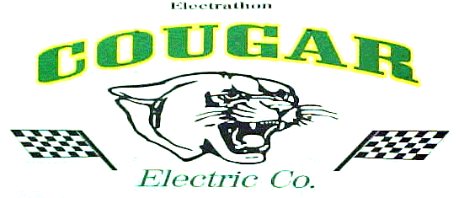
Kennedy Electric Car
(Cougar Electric Car Company)
Car 984, Advanced Class
Advisor: Barry Wilson

Contact Information:
School Address
l
Kennedy High School
c/o Barry Wilson (Advisor)
4545 Wenig Rd. NE
Cedar Rapids, IA 52402

Phone
g
Barry Wilson (Advisor)
(319) 558-1595 (school number)

E-mail
l
Advisor Email:
bwilson@crschools.us
Alternative Student E-mail:
cougarelectriccar@gmail.com

Website
l
www.cougarlectriccar.com

Social Media
l
Facebook:
Kennedy Electric Car Company
Instagram:
@cougarelectriccar

Electric Car at Kennedy

John F. Kennedy High School’s electric car program is called Cougar Electric Car Company. Our school and program are in Cedar Rapids, which is in east-central Iowa. Cougar Electric built its first car in 1998 to take part in the 1998-1999 race season. The program was originally held as an after-school class, but starting in 2016, it was added to the normal school day. All of the planning, designing, and assembly is done in the shop by students.
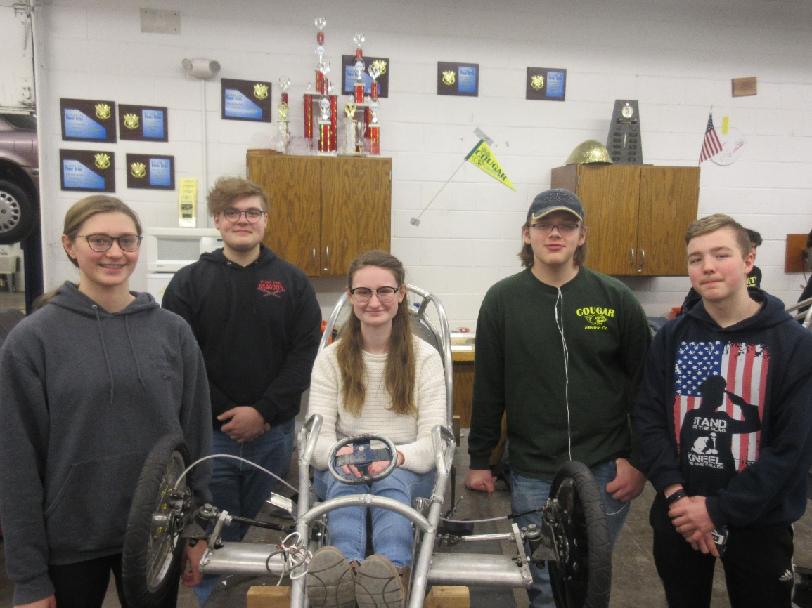

Car History

This 984 car was originally built by now graduated crew chief Derek Severson during the 2018-2019 school year. The 984 was an ambitious build for our program, as it is the smallest car we have ever built. Thanks to the slight framed senior Kaleigh Martin, the 984 is extremely light weight and small in diameter. However, the 984’s first season had a very slow start. Due to construction delays, it missed our first race of the season. Despite delays, the 984 team was able to round out the season with a very successful Wisconsin Championship. The 984 had the most successful heat our team has ever had, with the car coming in just 30 seconds short of 8 laps. It took 1st place for endurance and 2nd place for design. One of the biggest challenges the 984 experienced that season was its tendency to spin out and lose its rear wheel chain. Current crew chief Jakob Davis hopes to fix the car’s back gear alignment and shift the center of balance for better static stability. For the 2021 season, the 984 is under crew chief Jakob Davis for a second year, although this will be his first competitive season due to last year’s cancellations and being driven for a third season (second competitive) by driver Kaleigh Martin.
The 984 with its’ past crew chief Derek Severson during its first racing season
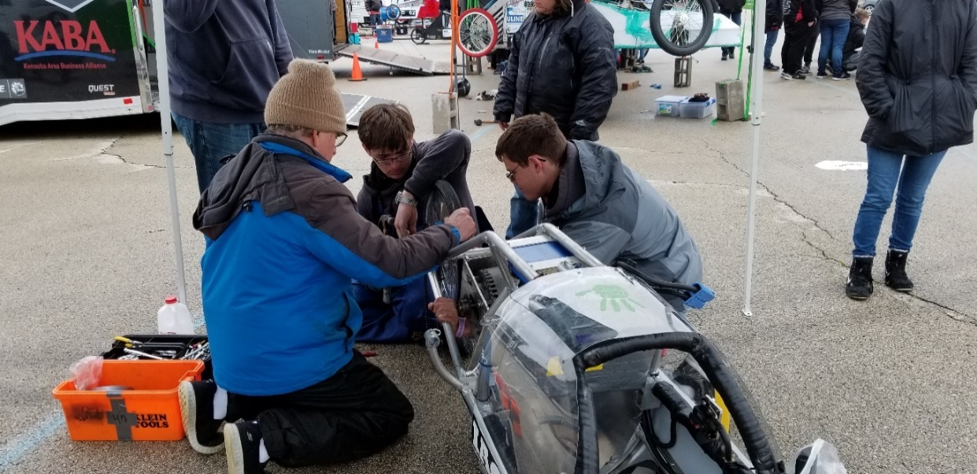

A Brief Overview of a Hectic Season

Our team’s 2019-2021 season was hectic from the get go. We had huge plans last winter: building two new cars, possibly building the program’s first lithium ion battery powered car, all while having two extremely new crew chiefs. The 984 car was the only car which wouldn’t be completely rebuilt, however crew chief Jakob Davis was in his first year in the role. The main issues of the car in its prior season was its tendency to spin out , so Jakob’s major modifications included chopping off and realigning the tail, as well as redoing the roll cage bars to make room in the cockpit to change the distribution of weight. By the time March 2020 rolled around, the 984 was the most put together out of the three. All of the frame work was finished and a body had been fitted, but the car had not been test driven yet. COVID-19 would halt the progress of the cars until at least the next fall, but Jakob was hopeful for a good season the next year.
If the challenges of COVID-19 were not enough for our program, then a derecho certainly would up the ante. On the muggy afternoon of August 10th, just two weeks before school would start back, a giant windstorm flattened Cedar Rapids. When we looked around after the storm, we were met with sights of homes without rooves, trees crushing buildings, and signs blown over flat. We would not start school online for over a month, with the possibility of being back in the classroom in late January, as our high school was the most damaged building in the school district. Extensive repairs were needed to all of the classrooms on the second floors, the office area, the auditorium, and gym as Kennedy was missing a large chunk of its roof. Lucky for our program, our shop was spared from any damage. Finally, mid-January rolled around, and we could start working on the cars again. Jakob Davis would return to his role as crew chief for a second year to try to finish what he started over a year ago.
As a note, due to the lack of a competitive season last year, the construction of this year’s car began in late 2019 and early 2020. Photos from that time are included in this book, so in some photos students are not wearing masks.

2021 Racing Schedule
Our team is making an effort to attend every race we possibly can this year. As of now, we are planning on racing in four states: Iowa, Nebraska, Wisconsin, and Michigan.

Race | Location | Date
West Point | West Point, NE | April 17th
Berlin | Grand Rapids, MI | April 30th
Wayne | Wayne, NE | May 1st
Road America | Elkhart Lake, WI | May 10th & May 11th
Hawkeye Downs | Cedar Rapids, IA | May 29th
Prairie | Cedar Rapids, IA | May 30th

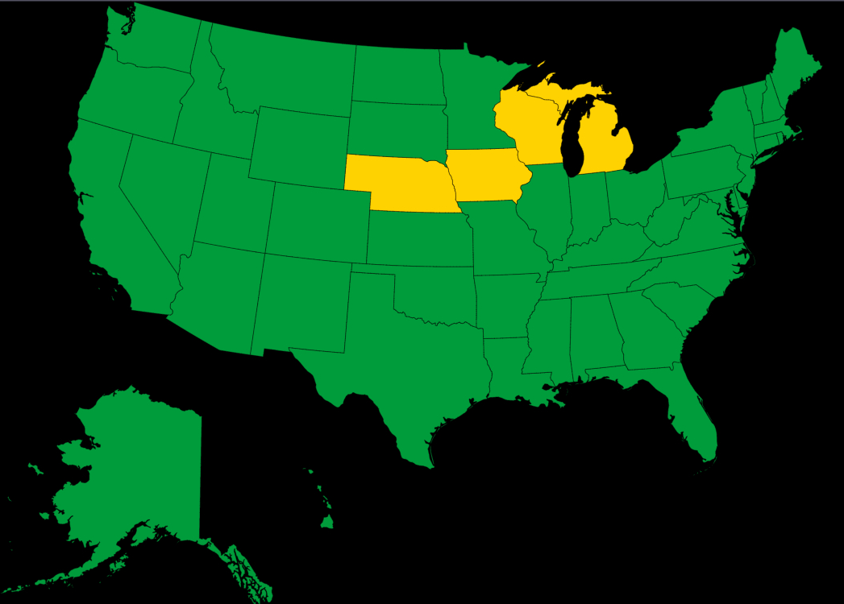

Team

Teams
Our full program includes ten individual teams a student can be a part of. We also refer to these teams as jobs, so a member of the batteries team can also be said to have batteries as a job. These ten teams fall under three categories: Mechanical Engineering, Electrical Engineering, and Promotions. Within these ten there also traveling and non-traveling teams. Electric Car is a class that is offered during the school day along with being an extracurricular activity. Not every student who is a member of the class travels with the team to races. The travel team consists of the students that regularly attend races. The bare minimum for the travel team has six students: three crew chiefs and three drivers. We usually have at least one parent accompanying us to races so we can bring along assistant crew chiefs, the batteries lead, and the telemetry lead. The latter two may also bring assistants, but the assistant crew chiefs and the batteries lead receive priority. Other students who do not travel also get to experience racing as it is required for students in the class to participate in the race we host every year at Hawkeye Downs. Non-traveling teams are integral to the overall program but do not have a job to do during races.

Mechanical Engineering
Crew Chief
Crew chiefs are the leaders of the class, each assigned one car and typically one assistant crew chief. They are in charge of putting all the individual parts together into a working car. They oversee and participate in the designing, building, wiring, and fixing of the cars. This year we are exploring more cooperation and teamwork across the three car teams in our program. In years past crew chiefs have exclusively worked on their cars. This year, while a single crew chief is still responsible for their car and has ultimate authority over their car, all three crew chiefs are to help with the design and construction of all three cars. Before our program only had crew chiefs helping each other with repairs at races, but now they are helping each other in the classroom. At races, crew chiefs are responsible for making sure the car passes inspections, performs to the best of its ability during heats, and handling any repairs that need to be made mid-race or in between heats. Through communication with the driver during the endurance heats, crew chiefs use battery information given to them by the batteries team to pace the car. Crew chiefs are all in all responsible for the success of their assigned car for the season. This is the 984’s crew chief Jakob’s second year in the role.
Assistant Crew Chief
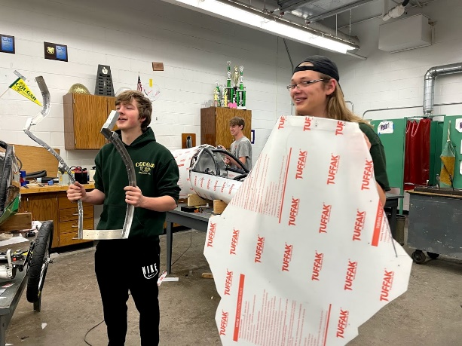
Assistant crew chiefs are the apprentices of the crew chief of their assigned car. While they are not responsible for any of the crew chief’s duties, they help in all areas of designing, building, and racing. Assistant crew chiefs are typically training to eventually take over as crew chief for the car they are apprenticing with. This year the 984’s crew chief this year is a junior with a junior assistant crew chief. As these two will be graduating at the same time, the current assistant crew chief won’t take over the 984 car. Instead, a younger student will need to replace the current 984 assistant crew chief within the next two years so the 984 is not taken over by a student who didn’t have the opportunity to apprentice. This is the 984’s assistant crew chief Mathew’s second year in the role.

Machinist
Our machinists work with the lathe and mill to make custom parts for our cars like our back axles and spacers. Both machinists this year are relatively new to the job, but not the program. We typically have older students train the incoming team members, but this wasn’t possible for machining this year, so our advisor Barry has been given that responsibility. Given that both team members have limited experience, neither has labeled ‘lead’ and the team instead works under Barry’s leadership. This is a non-traveling team.
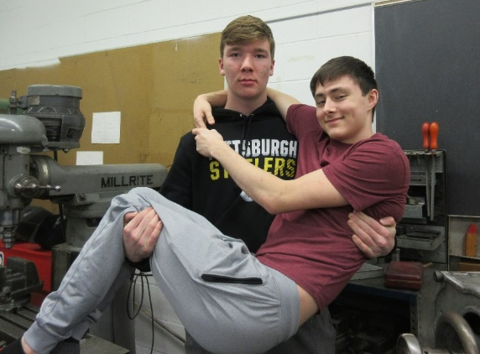
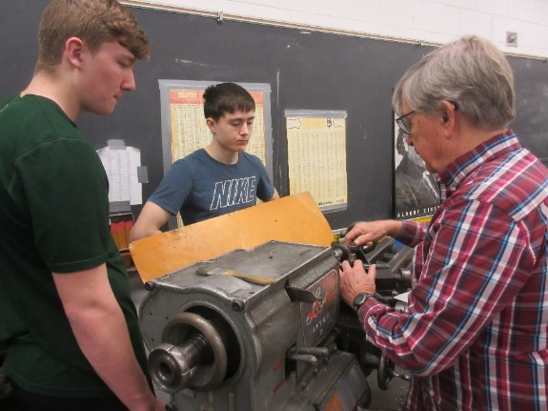

Aerodynamics and Design
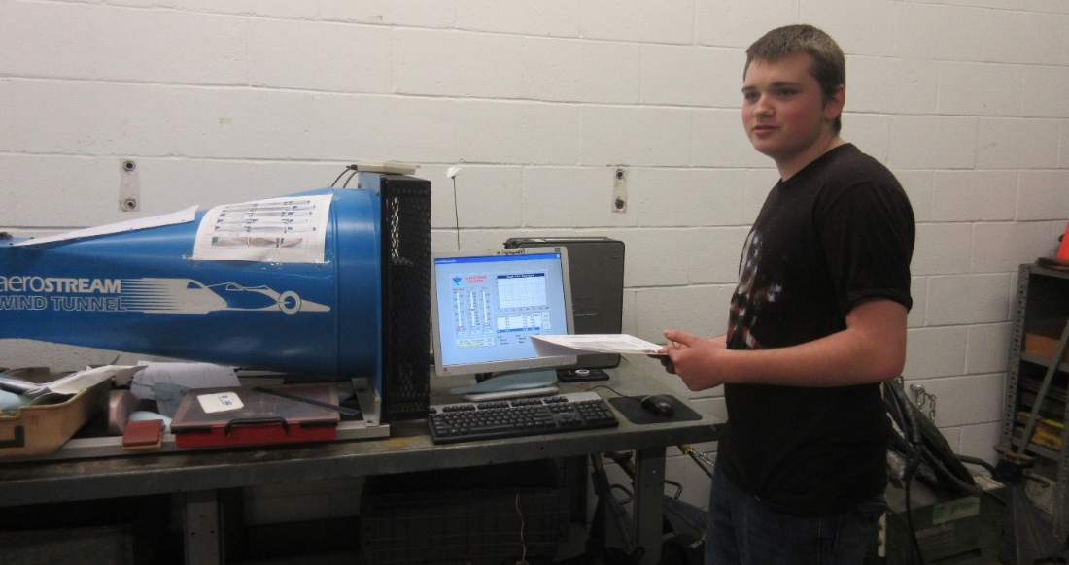
The aerodynamics and design team use a wind tunnel and 1/10 scale models they make of our cars to advise the crew chiefs of the design of their cars. They are either telling the crew chiefs where to make their car more aerodynamic, or if the crew chief is making a new car, which parts of other cars to copy, and what parts to do differently. Members are not a part of the traveling team and do their work exclusively in class. The current lead and lone member is Jesse Hempstead
Electrical Engineering
Batteries
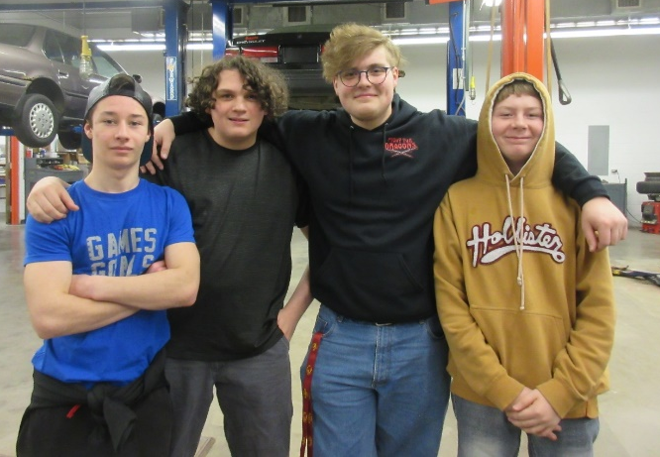
The batteries team is responsible for maintaining and caring for our batteries and deciding how to pair them for racing sets. They run a series of tests using our dyno, a device we use to simulating driving to see how the batteries run down. They use this data to designate ‘A’, ‘B’, and ‘set-up’ sets and create battery curves that tell crew chiefs where voltage should be at different times during races to make sure the car can run for the entire heat. While batteries are in protective storage to extend their life the batteries team is in charge of trailer maintenance. They clean, organize, and make any necessary repairs to the team trailer we bring to races. Noah Wilson is the batteries team’s lead and is typically the only batteries team member that travels. If there is space available an assistant may accompany the travel team as well. At races battery team members make sure batteries are on chargers or maintainers, decide which car gets which set of batteries, and are general helpers that can provide another set of hands to help with any repairs.
Telemetry
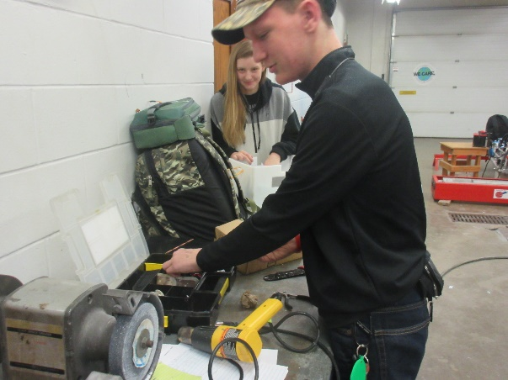
Telemetry is in charge of the communication pathways between the drivers, the crew chiefs, and the batteries. They work on the system that relays the batteries volts and amperage during races to both a display in the cockpit of the car and to the crew chiefs in the pits. The main goal of the team this year is finding a way to allow both the driver and the crew chiefs in the pits to see battery and amperage information instead of relying on verbal relaying. Telemetry often helps crew chiefs wire their cars to make sure their devices are properly installed. This team sometimes travels; at races, the telemetry team makes sure their system is working and tries to fix any issues with the hardware or software that may arise. The current lead is Brian Stubblefield.

Promotions
Promotions
Promotions is both an overhead and its own team. Promotions is an outreach team that communicates with both the public and sponsors. Members run our social medias (Facebook and Instagram) and maintain our website. These are used as ways to get the word out about our program, keep in touch with parents and former students, and give sponsors an idea of what the program does. The team communicates with sponsors to secure donations to keep our program running. They also make or organize all sponsor thank-yous. This is not a traveling team, but the team does post race results on our social medias and website using pictures and information from travel team members. This year there are no students whose sole job is promotions; the responsibilities of the promotions team are split between members of a variety of different teams. Our social medias are managed by our advisor Barry and telemetry lead Brian Stubblefield, the website and sponsor thank-yous are run by the documentation team, and sponsor communications are handled by Barry, the documentation team, and batteries lead Noah Wilson. With there not being any full-time members, this team does not have a lead.

Documentation
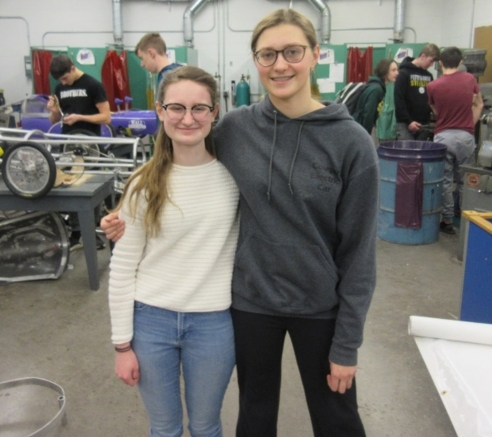
The documentation team is responsible for making the documentation books and monthly log books that are submitted for scores that add to each car’s overall season points. Due to the lack of a dedicated promotions team, the documentation team also handling sponsor communications and running the program’s website this year. In years past the documentation has an assigned a car to each member to write about with a lead approving final copies, this year the team is working collaboratively on all three car’s books. The documentation team does not travel.

Graphics
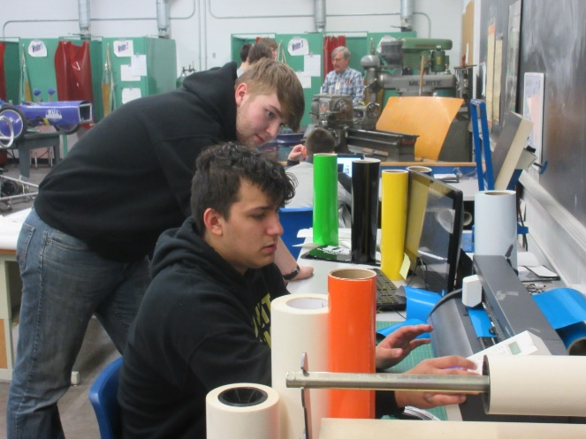
The graphics teams work with a Roland vinyl sheet cutter and by hand to create the graphics for the cars the travel team trailer, team t-shirts, sweatshirts, and promotional materials. The team also designs any graphics that are not sponsor logos. Along with making t-shirts and sweatshirts the team manages all parts of the ordering process and is in direct contact with customers. The graphics team lead is currently Kiera Zortman.

Drivers
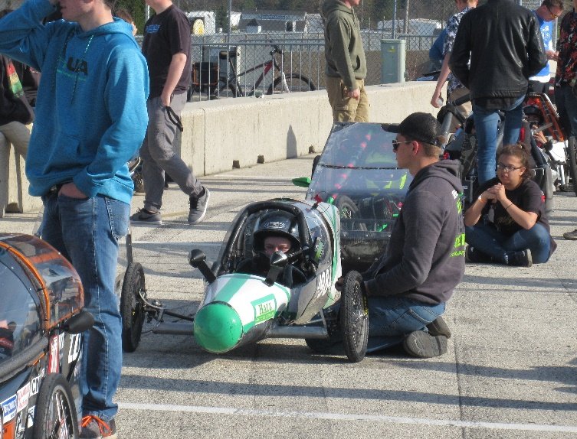
Drivers do exactly as the name says. They typically only have one car that they drive and that car is usually built around them using their measurements. Drivers also fill this role outside of races by participating in practice laps, maneuverability runs, and braking practice on weekends when we can use the empty school parking lot. They also attend events to either tell people about driving and the program or to drive in parades or demonstrations. Driving doesn’t have any class duties, just racing duties. Because of this, the drivers have another job within our team. The other job is not typically one that is a part of the travel team. This year the 984’s driver is Kaleigh Martin who is also the documentation team lead.

984 Travel Team Members
984 Crew Chief
Jakob Davis
Jakob is a sophomore in his second year in the program, who works as the 984’s crew chief. He runs a crew of aspiring sophomore assistant crew chiefs to maintain our program's smallest car. He plans on becoming a machinist after high school. In his free time, he can often be found in the shop or watching western movies.
Quote: “We are now the Cougar Cleaning service! We are done with all those cars!”

984 Assistant Crew Chief
Mathew Morrow

Junior Mathew is the 984’s assistant crew chief learning under Jakob Davis. He started under John with the 983 but moved to help with the 984 when it was undergoing its two major modifications. After high school, he would like to become a part of his family’s tow truck business.
Quote: “There’s hills, hills, and more hills. If you need brakes, you need Jesus.”

Documentation and 984 Driver
Kaleigh Martin
Senior Kaleigh is in her third year in the program and has been the Documentation Lead and the driver of the 984 car all three years. She was encouraged by our advisor Barry to join the program so the team could have some fun building our smallest car yet around her short stature. Kaleigh is also involved in our school’s Speech team and Green Bandana. She plans on becoming a high school history teacher after her time at Kennedy.
Quote: “Tomorrow is a new day.”

Documentation and 985 Driver
Elizabeth Severson
This is senior Elizabeth Severson’s second year on the documentation team, but her third year in the program. In addition to being on the documentation team, Elizabeth is also a driver for the 985 car. However, as the youngest sibling in an electric car family, she has been involved in the program in some way since middle school. Outside of the program, Elizabeth enjoys swimming and piano. She hopes to study agronomy or international food systems after high school.
Quote: “We could steal Barry’s umbrella.”

Batteries Lead
Noah Wilson

Noah is a junior who has been with the Electric car program for three years. During his time on the team, Noah has served as the Head of the Battery department and had many trainees come through his program. Whenever he can, Noah tries to have fun and help new members find as much joy in Electric car as they can. You will often find that if Noah has his recruits doing a project or if he isn’t directly needed to help in Batteries he will find a way to help another team as he is knowledgeable in many subjects of the shop. Noah proudly calls himself a Thespian as he has been in almost every theatrical performance he could while at Kennedy. Along with Theatre, Noah finds great joy being in the Varsity Show Choir and on the Varsity Bowling Team. An interesting thing about Noah is that his dad is GM at the Cedar Rapids Kernels and Noah has worked as the Batboy for a couple of years, through this Noah has met famous players such as Mike Trout, Byron Buxton, Hofer Trevor Hoffman, and many more. After high school Noah wishes to study Forensic sciences or explore CTE certified teaching as a career.
Quote: “We had a Navy when Barry fought in the War of 1812?
984 Non-Travel Team Members
Machinists
Machinist
Dylan Davis
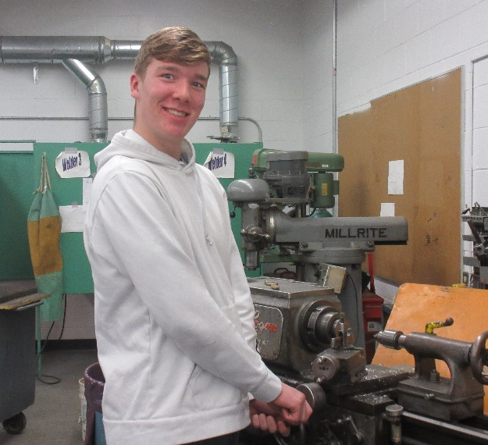
Junior Dylan Davis is a great addition to the machinists. Dylan has been apart of almost every team in the program, as he was briefly on the documentation team, an assistant crew chief, a graphics team member, and a machinist. Dylan enjoys playing football and basketball and aspires to work in the trades.
Quote: “get ‘er done”

Machinist
Tyler Barz
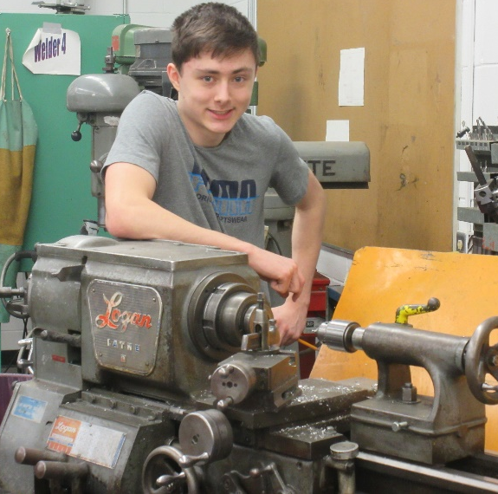

Junior Tyler Barz is a talented software developer who is fluent in python3 and c# and has been developing for almost four years. Outside of school he enjoys hitting the rink to play hockey. This year he plans on continuing to hone his skills on the lathe as a machinist. He hopes to study computer science and software development after high school.
Quote: “Are we in Mormon city? No, we’re in Fond de Lac, Wisconsin”

Aerodynamics
Aerodynamics Lead
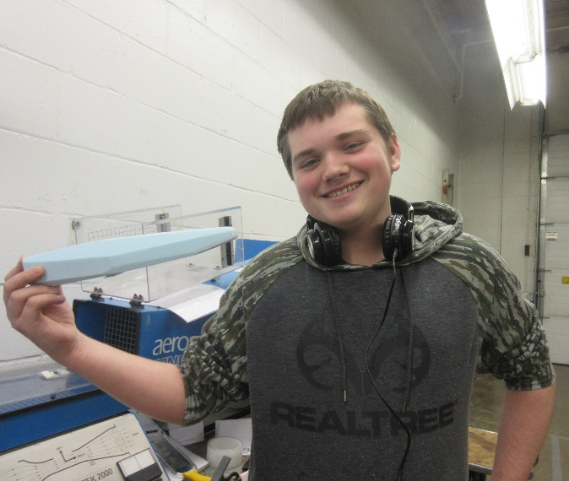
Jesse Hempstead

Jesse works as our team’s aerodynamics leader, working directly with the crew chiefs and our advisor to design each new car. His prior experience as the 984’s assistant crew chief has given him many insights into the program that he plans to bring into his car designs. He plans to join the military after high school.
Quote: “I’ve given up with everything by now”

Batteries
Batteries Lead
Noah Wilson
Noah’s team profile can found on page blah in the 984’s travel team section, as the battery lead is integral to the success of the cars and always travels with the team to races.
Batteries
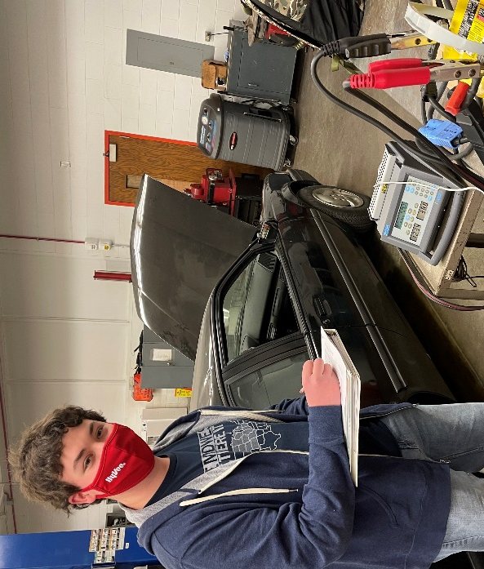
Colton Staudacher

This is junior Colton Staudacher’s first year in electric car, where he works on the battery team. He is heavily involved in band; performing in the marching band, concert band, jazz band, and show choir combo band. In addition to band, Colton also participates in the Kennedy Trap Club.
Quote: “I’m not here for a long time, just a good time.”

Telemetry
Telemetry Lead
Brian Stubblefield
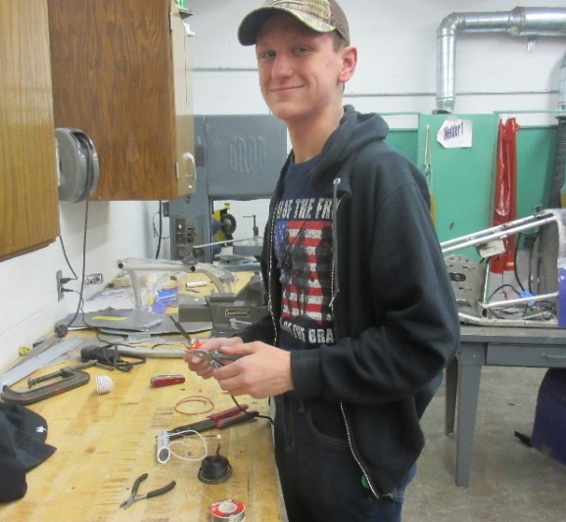
Brian Stubblefield, often affectionately called Stubbs, is in his third year as head of the telemetry department. As a freshman, in addition to telemetry, he dabbled in documentation. Ultimately deciding that writing was not his forte, he returned to telemetry in his sophomore year and has now tried his hand at electric engineering as a junior. He plans on attending the paramedic program at Kirkwood Community College after high school, with the goal of joining the Cedar Rapids Fire Department.
Quote: “Barry, I’m gonna go run.”

Graphics
Graphics Lead
Kiera Zortman
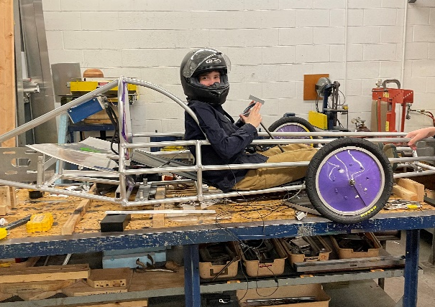
Keira Zortman is a freshman this year. Originally hailing from Mississippi, Keira is a bright character who enjoys welding, dirt bike racing, and basketball. She is joining the team as a driver and the graphics team lead for the second semester. She is extremely excited to be a part of the program.
Quote: “Jah!”

Graphics
Kaylee Osborn
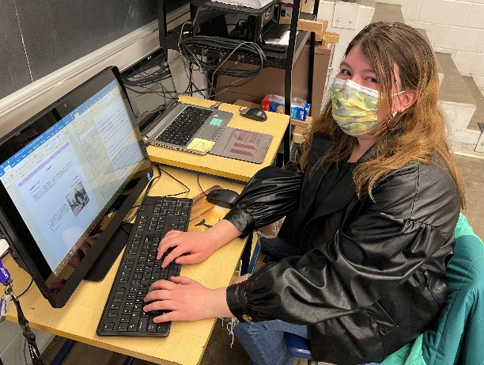
Freshman Kaylee Osborn is a new addition to the electric car team this semester. She was originally interested in the program as a middle schooler, as her older brother participated as a crew chief. As a talented artist and writer, she will be trying her hand at leading graphics as well as simultaneously being an understudy for the documentation team. She is also involved in volleyball and dance at Kennedy.
Quote: “Just be yourself; everybody else is taken.”

Graphics
Trevor Montgomery-Provencher
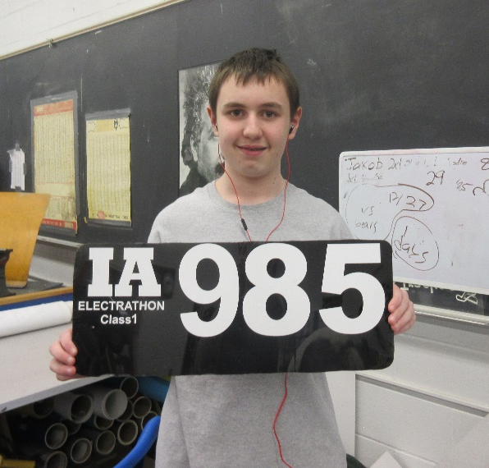

Freshman Trevor is a new member of electric car. He came in with some experience working with our graphics tools making him a great addition to the team. He is a self-proclaimed gamer and is unsure of what to do with his life after high school.
Quote: “I always try to split my time.

Original Design and Construction

Research Notes

The original design of the 984 car was designed by former and now graduated crew chief Derek Severson. His main goals in building the car were to make the smallest, lightest car possible. Due to how sleight and short his driver is, he was able to pull of designing the smallest car the program has ever built. The aerodynamics of the car are based on the British-French Concorde airplane, which has a similar shape to a cigar. Below are some of his research notes and calculations he made when first designing the car.
- Round frame design eliminates weight by reducing car-length frame rails from 6 to 5.
- Round design evenly distributes air around the car, reducing downforce.
- Slightly raised nose to more evenly split air around the body, and allow the use of a straight axle.
- Skeletonized mounting plates for electronics: This saves about ½ a pound in the car (equal to around 2 feet of 1 in. aluminum tubing).
- Batteries placed long-ways in the car in order to lower them 2 inches in the frame for a lower center of gravity.
- Permanent Rear axle; this eliminates the swing arm system which could save up to 20 lbs. with minimal performance impact.
- Polycarbonate open-back tail: Molded tails tend to be very fragile and seems to have trap air around the rear wheel. A well-designed open-back tail will allow air to escape, while still cleanly putting air back together.
- Aluminum Axle built from a Cessna wing strut. Previous designs used an all steel construction, purely for strength. This aluminum design should be very strong, aerodynamic and cut 5 to 10 lbs. from the car.
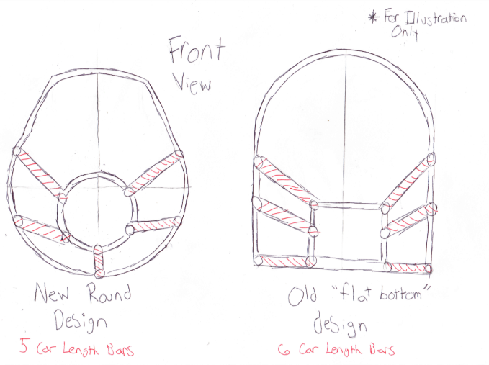
- Use of only 1” OD .083 Wall aluminum. The last car had some rails made of 1 ½” OD .083 tubing for ease of manufacture. This change saves .1542 lbs. per foot
Round Bottomed vs. Flat Bottomed Design
Skeletonized Controller Mount
Original Design Drawings

These are the drawings Derek used as a reference to build the car off of. These include detailed measurements of each and every tube that would be used. Below is the final drawing of the side view of the car.

motor

This is the top view of the car

These are sketches of each of the main rings that make up the body

Frame Materials

Our frames are all made from the same basic components. The main frame members are 0.083” thick 1 inch aluminum tubing, while the belly pan and firewall are 0.03” thick aluminum sheeting. We use the thinnest aluminum tubing allowed in an effort to reduce the overall weight of the car. The canopy and tail cover frames are bent out of 1 inch aluminum angle. Additionally, the controller mounts and rear wheel mounts are cut out of ¼ inch aluminum sheets.
The 984’s axle made out of an aluminum Cessna airplane wing strut. The wing strut is much more aerodynamic then the typical all steel axles the program usually builds, while also being 5-10 pounds lighter. The wing strut was stripped of its paint to expose the aluminum underneath, then cut to fit the car. A ¼ inch steel end cap was welded onto the end of the wing strut to provide a place for the steel tire knuckles to bolt onto.
The padding we use to cover our frame members in the cockpit is 1/2-inch gray, thin pool-noodle-like foam tubing. We attach the padding to the tubing by tightly winding electrical tape along the entire length of the noddle. This allows all wiring and sharp metal to be tucked away beneath the padding, giving the driver a safer cockpit.
We special order our car’s wheels. After years of testing, we have found that wheels that have extra thick spokes and are smaller in diameter hold up much better during races. Our rear wheel is the largest wheel, with a diameter of 20 inches and the two front wheels are 15 inches in diameter.

The First Frame
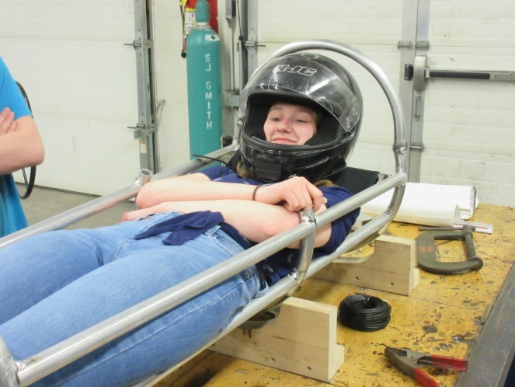
After creating custom wood jigs, Derek and his assistant crew chief Jesse Hempstead got to work rolling the aluminum tubing into four circles. An 8” diameter full circle for the nose, a second full circle to form the front cockpit, and two ¾ circles that would help form the lower roller cage. Once the circles were finished, creating the sides out of straight pipes was a piece of cake. Derek finished off the car with the tail and controllers. However, when he fit his driver in the car with the controllers, it became apparent that it was just too tight. With the first race glaring at him in less than a week, Derek wasn’t sure what he was going to do.
Driver Kaleigh Martin in the first 984 frame.

Finally, a Car!
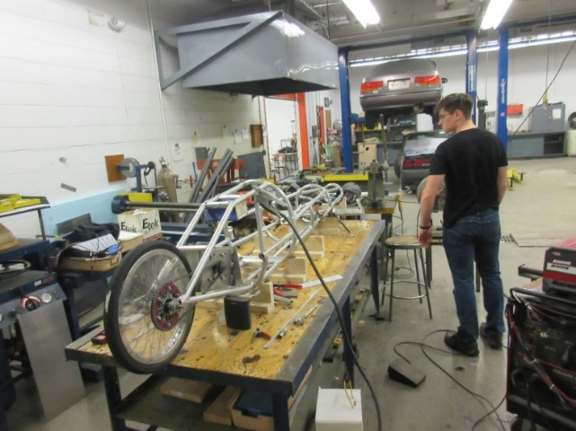
A very frustrated crew chief now was facing having to almost completely redoing his frame, but with bigger hoops and a larger roll cage. With many late evenings after school and weekend mornings, the car was rebuilt in record time (about 2 weeks). As this was such a whirlwind effort, most of the process did not get recorded. Memorable moments included welding together two steel cylinders to create a custom weight for under the battery box and trying to weld a canopy frame in position on an already padded frame without setting the car on fire. Due to such a huge delay, the 984 did not make to the first race. However, by the second race of the season it was finally ready to go.
The second frame while it was getting its final welds done.

Design Flaws We Found Racing
By the last race of the season, some major design flaws were very apparent. The 984 had a very bad habit of spinning out, especially when the track was wet. At the only race it actively rained at, the 984 spun out 8 times in a single heat. Additionally, it spun out an additional two times on perfectly dry tracks. This was most likely due to the strange weight distribution the original design had. Due to the driver only weighing around 100 pounds at the time, the car needed a significant amount of ballast to fulfill the 150 pound minimum in Wisconsin. Most of this ballast was located either under the battery box or the motor controller in the tail of the car, pushing the weight distribution towards the back of the car on the rear wheel. This combined with the 984 being rear ended at one of its first races of the season putting the rear wheel out of alignment was most likely the cause of the car spinning out. The 984 also often threw chains multiple times per heat. The crew chief that would ultimately take over the car by for the next season, Jakob Davis, wanted to fix these two problems, as they often caused the 984 to need lots of time in the pits at races.

Modifications

Timelines

2020
January 2020
Reframe Tail | Roll Bars and Belly Pan

February 2020
Wiring and Brakes | Foam Padding | Body Panels

March 2020
Body Panels continued | The Longest Spring Break

2021
January 2021
Getting Back Into It | Body Panels

February 2021
Body Panels | Rear Wheel Mount | Wiring 2.0 | Padding

March 2021
Canopy

April 2021
Testing

A New Tail

First things first for Jakob was fixing the alignment of the tail. This included completely chopping the tail off of the car, then building a new frame. Jakob hopes that a new tail will help to fix at least the 984s tendency to constantly drop its rear wheel chain, and maybe help with the spinning.
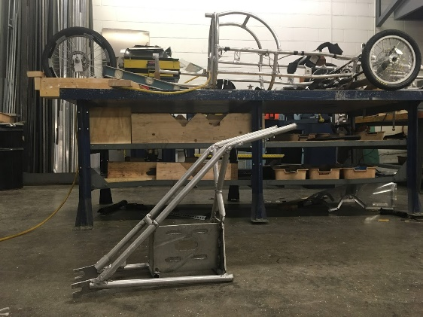
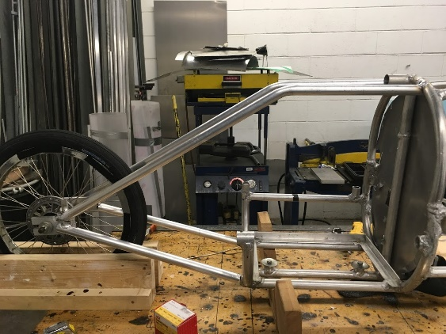

The new tail with a dramatically different construction
The old tail cut off the frame. Notice the right triangle construction.

Motor
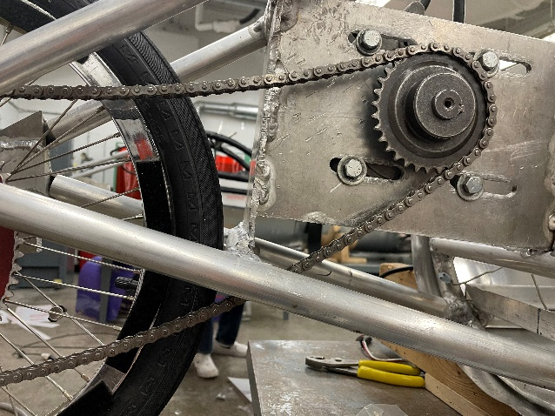
With the new tail design came a new motor mount. Last season the 984 used two different motors, a Briggs E-Tech and a Saietta. The two motors needed different shaped mounts so the old 984 tail included a convertible mount. This year however, the 984 will only be running a Saietta. Part of the reason we ran two different motors was because last season was only our second year using a Saietta and we wanted the ability to switch the motor if it was underperforming. This season we are more familiar a Saietta and are happy with its performance, so it will be the only motor we will be using. The main appeal of the Saietta is its ability to draw little to no amps after getting up to speed. The Saietta mount is circular and that shape is hard to weld to the car and the diameter cannot be changed to fit the space. So instead of the mount being directly to the car, the circular mount is attached to a rectangular piece of aluminum which is welded to the tail.
The Weight Dilemma

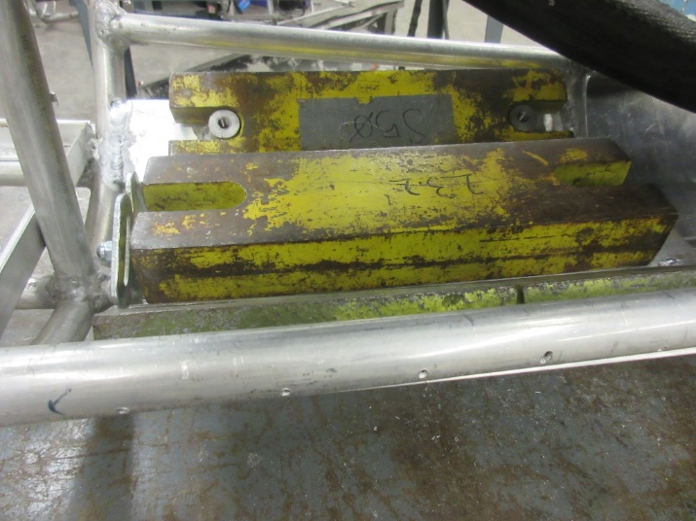
The original design of the 984 had two places for ballast weights. One custom weight made out of welded together steel rods (about 30 lbs) and one weight rack underneath the driver directly in front of the fire wall (about 20 lbs). As the 984 need so much weight to make the minimum weight requirements, it was easy to move with weight within the car to change the center of balance and static stability. Due to chopping of the tail, the measurements of the car were different then in 2019. So Barry decided it would be best to move all of the weights to underneath the seat, which would in comparison to the 2019 would change the center of balance more towards the rear of the car. This would hopefully help to keep the cars tail from fishtailing on the driver. However, this change meant the seat needed to be moved up, which would cause the roll cage bars to be too short. After a riff with our advisor, Jakob reluctantly moved the weights to the front of the cockpit. Jakob did not want to redo the roll cage at all, as the car already had quite a dramatic cockpit, and he was concerned about what an even taller cockpit would do the aerodynamics. In the end Jakob opted for what our advisor called “bubble bars”, and neither seemed all too happy about the change.
The weights underneath the seat, in front of the firewall
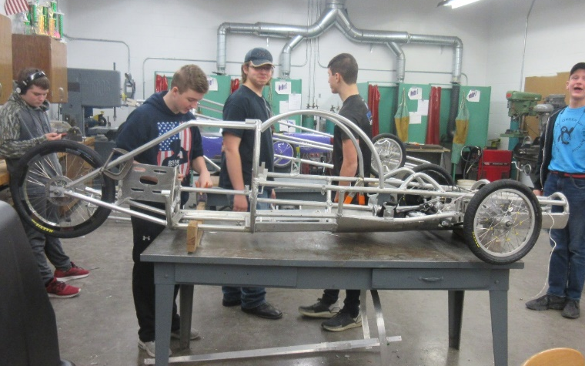
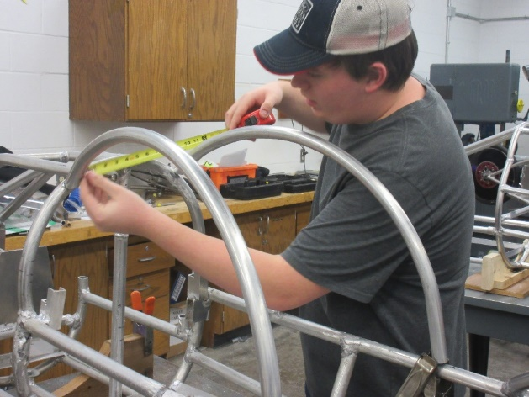

The 984 with its new roll cage

Former assistant crew chief Avery fitting the new roll cage

Centers

New Belly Pan

With the major framework finished up, Jakob got started on creating a new belly pan. He cut out rectangular pieces out of 0.03 inch aluminum sheets with the industrial metal shear, and rolled them to fit onto the circular frame with the metal roller. Jakob moved his team onto installing a belly pan. The 984 had a large crew of assistant crew chiefs and mechanical engineers during the spring of 2020, so Jakob was truly just supervising his crew while they riveted on the aluminum sheet metal onto the bottom of the car. With extra hands to hold the sheet metal into place, the job went quite quickly. Jakob hopes that a better fitting belly pan will help to decrease the drag the car experiences, as well as keep his driver dry and safe during inclement weather.
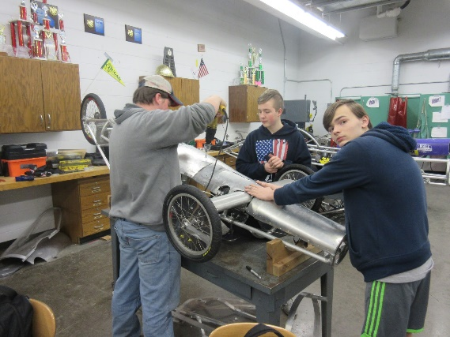
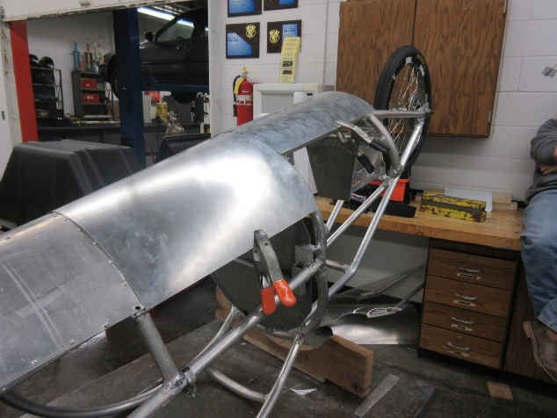
The 984 team riveting on the belly pan
The belly pan nearly completed

Padding and Body

Now that the wiring was done, Jakob could add on the foam padding and start in on adding body panels. Foam pool-noodle like padding is added onto the frame within the cockpit, both to help ensure the safety of the driver and to conceal the wiring so it doesn’t get damaged. Jakob measured out the foam noodles and attached them to the frame by tightly winding electrical tape around the entire length. Jakob the guided his team and Stubbs to cut up polycarbonate sheets into body panels to be riveted onto the frame.

The 984 cockpit mostly padded up. All of the foam as been secured with tightly wound electrical tape
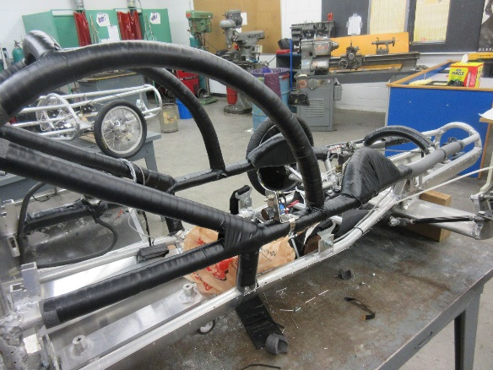
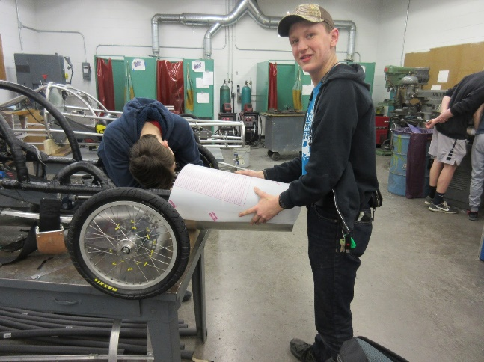

Stubbs and a mechanical engineer fitting on one of the body panels. Riveting body panels is easiest with two people, as one can hold the plastic tight to the frame while the other operated the rivet gun.
The Longest Spring Break

By the time spring break had rolled around, Jakob had finished cutting out and fitting the body panels onto the car. He was really hoping to get the opportunity to work on spray painting his body panels and starting in the construction of the canopy over spring break. However, everyone was locked out the building for the rest year after March 13, 2020. Still hopeful to race, Jakob offered to transport the electric cars to his father’s farm to continue construction, but as they are school property this was not allowed. All construction was halted until January of 2021, due to COVID precautions and the repairs our school building had to undergo after the derecho in August.
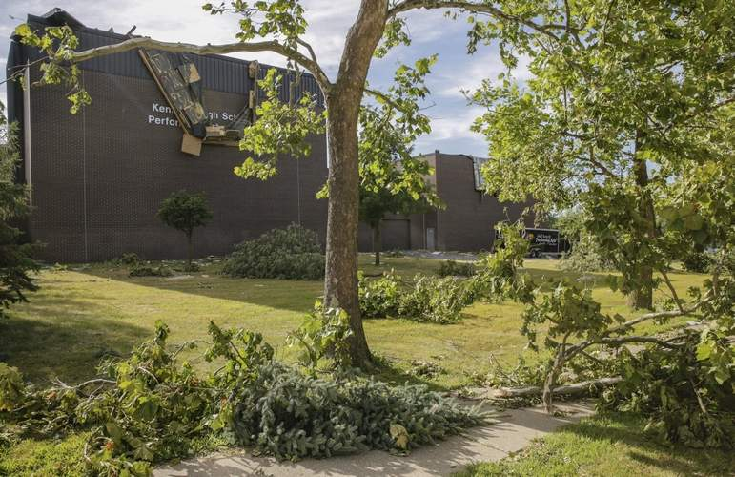

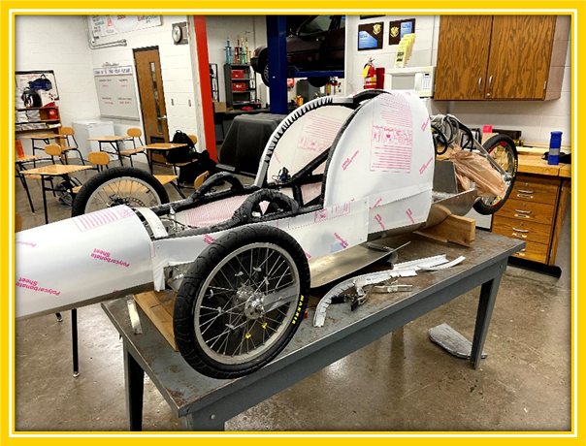
Kennedy shortly after the derecho
(Jim Slosiarek/The Gazette)
The 984 before spring break
The chain rubbing on the tube
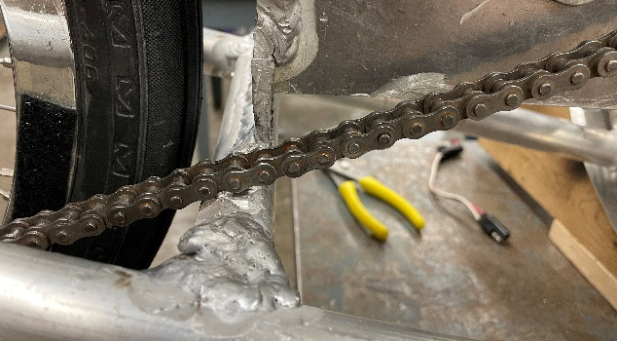
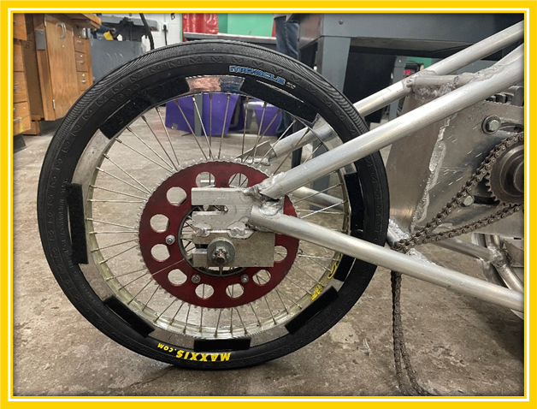
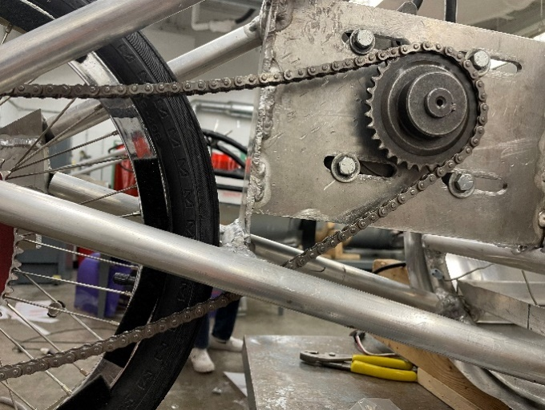
The chain running below the tube
The new rear wheel mount welded below the old one

Wiring

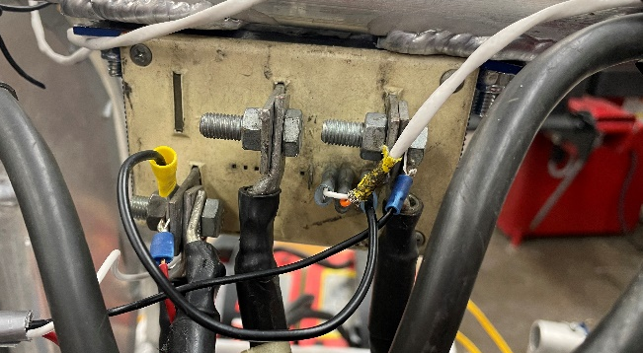
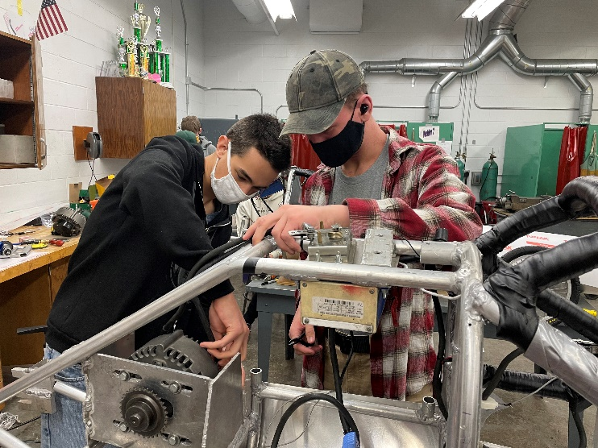
Occasionally, the crew chief hook up the cars to a set of batteries to make sure everything is working okay. Upon connecting the batteries to the 984, Jakob discovered, much to his surprise and demise, the car did not run at all. With the help of the telemetry lead, Stubbs, and his assistant Bence, they were able to figure out the problem stemmed from the wiring of the motor controller. Somehow, last spring when the car was wired, every wire was placed one terminal to the left. This was especially confusing to the team as it truly looked like the motor controller was wired correctly. Upon further inspection by Stubbs, he found that the motor was wired backward and the potentiometer had a broken connector. Finally, with the motor controller and the motor rewired, as well as an installation of a new potentiometer, the team was hoping it was all good to go. The car turned on! But (unfortunately there is always a but) the potentiometer did work. Jakob believed that Stubbs wired it incorrectly when he installed it. At this point, Noah Wilson, the battery team lead stepped in. Noah fixed the wiring on the potentiometer and checked over the rest of the wiring just to be sure. After confirmation from the documentation team that it was Stubbs who helped him wire the car last spring, Jakob has decided to only trust Noah with wiring from now on. Since this fiasco, Noah has helped Jakob wire up his brake lights.
The now correctly wired motor controller
Stubbs and Bence working on the wiring

Those Bubble Bars Pose an Issue

Since Jakob made such a significant alteration to the roll cage, last season’s canopy would no longer fit onto the car. Since it was spring break, it was just Jakob and his new assistant crew chief Mathew Morrow. Wielding 1 inch angle and a rough plan of action the boys got to work creating the frame. By cutting out many slits into one side of the 1 inch angle with the band saw they could create the bent pieces to go over the roll cage. Then with a hodgepodge of aluminum and some questionable jigging, a metal frame was tacked together. The real trouble began when the boys attempted to rivet polycarbonate onto the frame. Polycarbonate will only willingly roll in one direction without exerting quite a bit of force on it and the metal frame. In this case, the polycarbonate was much stronger than the metal frame, and bent the frame enough so that it no longer fit onto the car. With some more fussing to attempt to salvage the canopy, the frame broke. Jakob and Mathew now had shield instead of a canopy.
Jakob had known from the get go that the canopy would be a challenge to build and during this process severely regretted procrastinating building it for this long. As he said, “I really wish I was back to a year ago laughing about how terrible this would be. “After a lackluster brainstorming session, the boys decided to call it a day and grabbed some mac and cheese and a milkshake from a local restaurant and went home to sleep on it.
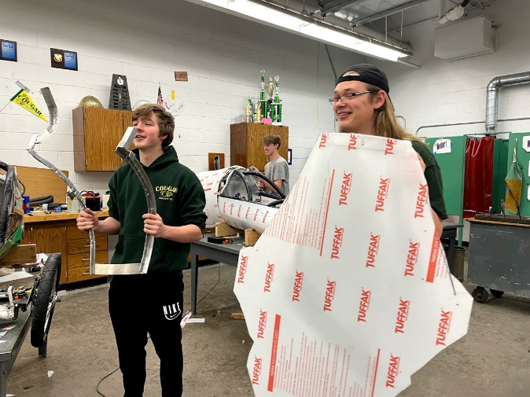

Jakob holding his “shield” and Mathew holding what was left of the frame
The canopy frame sitting on top of the car
A Successful Canopy!

The next day, the boys decided to try something different. By having the bent roll cage frame members on the outside of the car instead of the inside, it would reduce the number of directions the polycarbonate would have to roll. Additionally, not having the canopy go all the way up to the polycarbonate would decrease the stress on the polycarbonate. This design work significantly better than the last design! The boys were able to rivet on polycarbonate with no problems. A successful canopy at last!

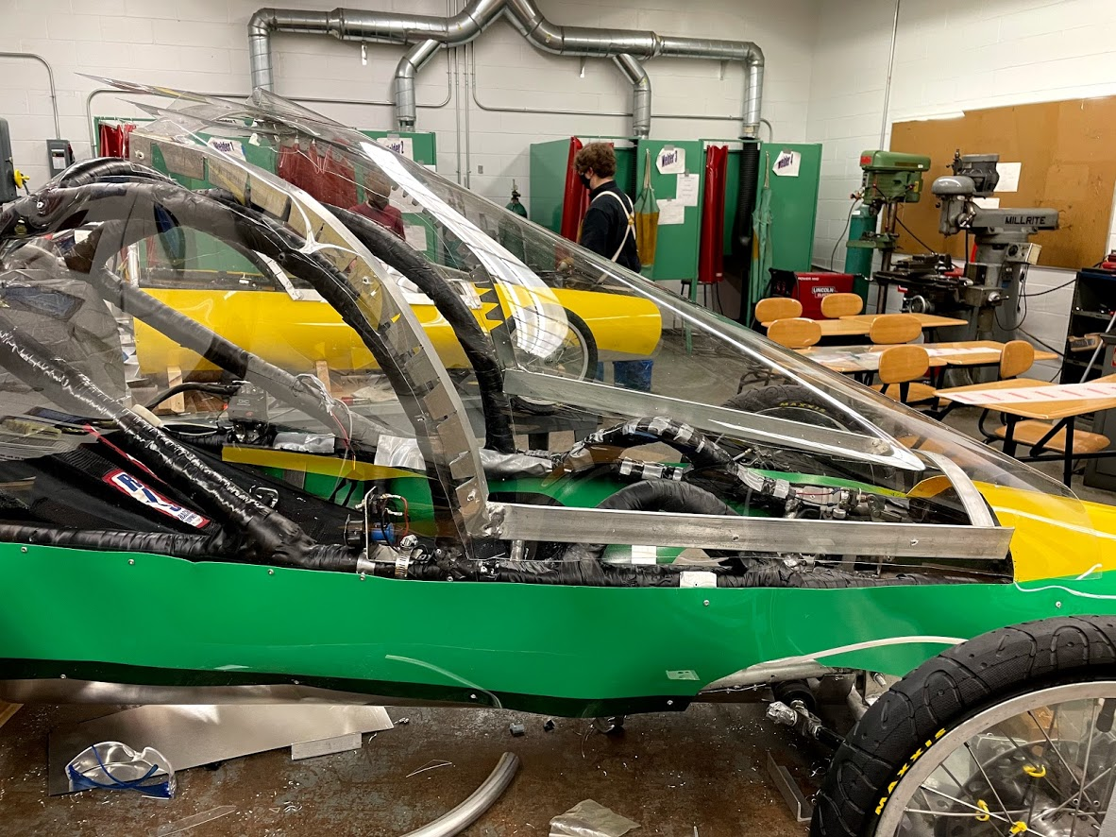

Body

Jakob has been working on the paint design for much of the year. Originally in 2020, Jakob was thinking of doing a teal and orange design based on the Ford GT 40 race car. After revisiting this design in 2021, he was not too happy with it. While design a new paint scheme Jakob had to keep in mind the color of the other Kennedy cars (to ensure easy counting during races) as well as the readability of sponsor logos. In the end he settled on a dark green, light green, and yellow paint scheme based on the Jamaican flag. His driver, Kaleigh Martin was quite surprised by both the switch and his inspiration. After drawing up his design, Jakob did multiple test pieces on polycarbonate to make sure the paint correctly adhered, a lesson he learned from the past crew chief of the 984. Confident his paint would last, Jakob took his pieces home and painstakingly masked off and sprayed his design onto the front cockpit body panel. His body panel came out great and he was almost over the finish line, with only the tail left to pain solid light green. Jakob allowed our advisor to spray out the tail, with the caveat that if our advisor couldn’t find the right color, Jakob would take the piece home and do it himself. Unfortunately, our advisor didn’t get the right color, so the 984 now has a rather mismatched tail.
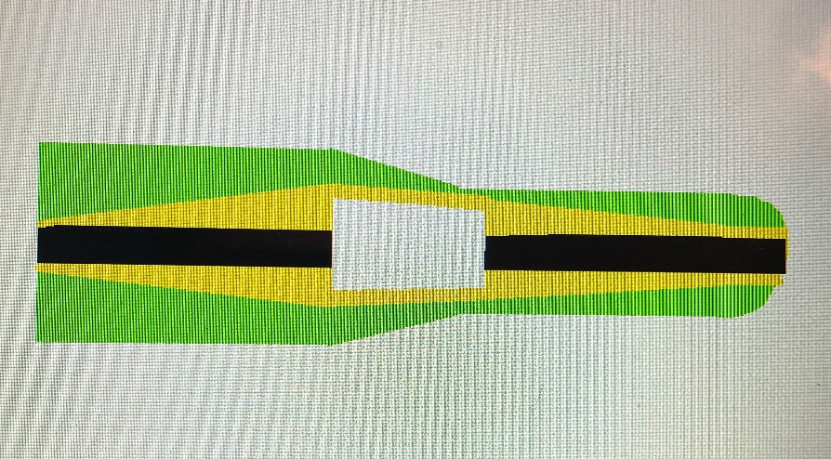
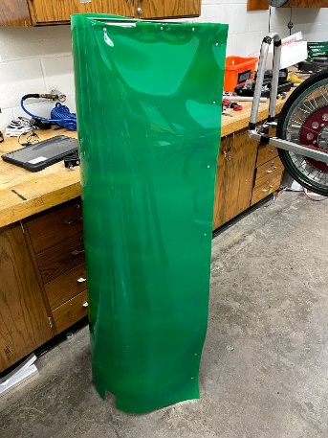

When Jakob looked at his car’s body, he was not happy with how many different panels it was made up with. The extra seems and rivets not only would affect the aerodynamics of the car but were also unsightly. So, Jakob completely scraped his body, and with the help of a significantly smaller team (Yay!) he carefully measured and cut out just one piece for his upper cockpit and sides, one piece for the roll bar, and one piece to cover the tail cover. After riveting everything on, Jakob was much happier with this body.
The old body made out of 6 separate panels

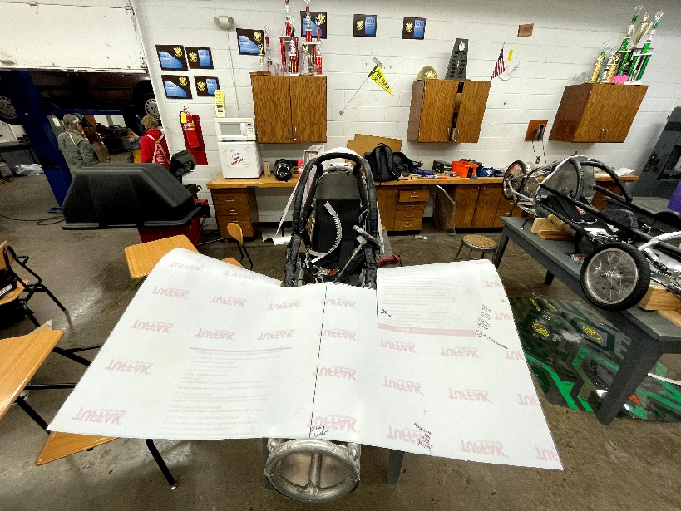

Carefully planning out the front cockpit and side piece

A New Body Continued
A rough fitting for the sides
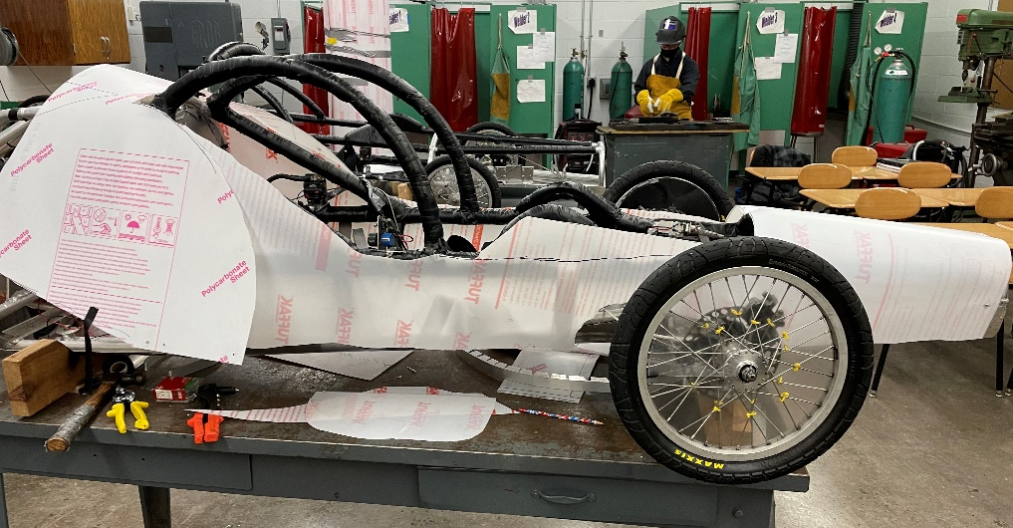
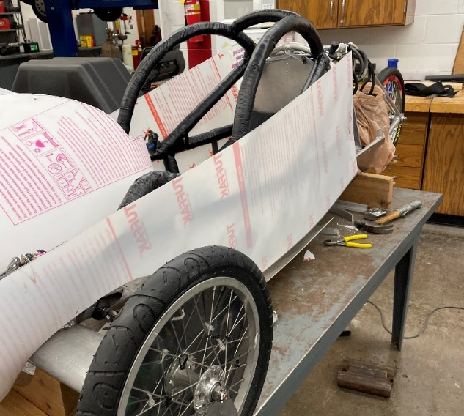
Better fitting sides featuring the roll cage piece
The tail

Batteries and Controllers

Batteries and testing
controllers

Testing

Exit and Vision test
Practice laps

Problems found and Modifications

Fundraising
Sponsors and Events

Events

As a team, we typically attend a variety of events including parades, expos, and open houses along with hosting two major fundraisers throughout the year. While we only bring a single car to some of these outreach opportunities, we always attend on behalf of everyone in the program. We usually have around nine events that we attend or host, but this last year we were unable to attend any. This section will document events our team attended during the time from early 2019 to early 2020. During this timeframe, we were still able to attend six events, and most importantly host our two fundraisers. There is no true distinction between events that are for marketing and events for public relations. We keep both ideas in mind at all events, as we believe that there could always be a business, an individual, or a parent that could see us and want to sponsor us or there is a student or future student that would want to the program or a similar program someday. The events we attended or hosted are listed below along with what type of event they are.

Parades | Expos | Open Houses | Fundraisers
Palo Parade | Marion Fly-In Breakfast  Kennedy Club Fair  Open Minds Open Doors STEM Expo | Kennedy Fall Open House  Kennedy Class of 2024 Incoming Freshmen Orientation | Fall Dinner  Hawkeye Downs (Concessions)

Marion Fly-In Breakfast
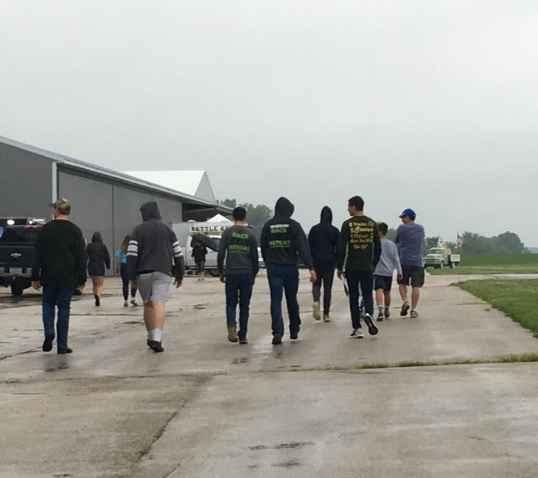
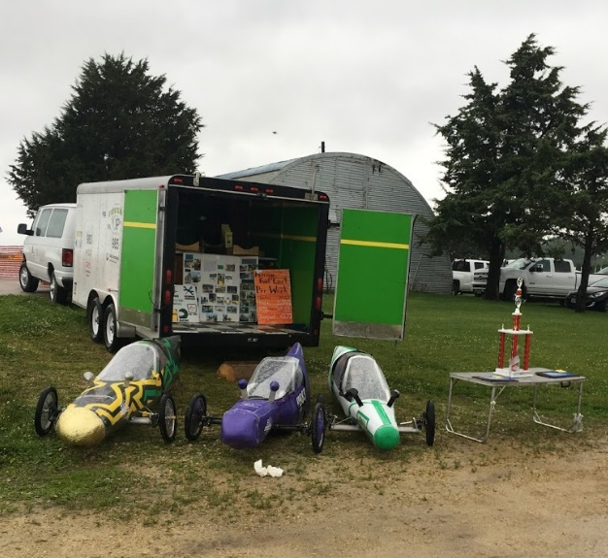
Our team was very excited to participate in the annual Marion Fly-In Breakfast at the Marion airport last summer. The Fly-In Breakfast is part of Cedar Rapids’ Fourth of July festivities and features a variety of displays and events. Displays included small aircrafts, classic cars, firetrucks, and police cars, while the events featured are airplane/helicopter rides and a warm pancake breakfast. This event allows our team to advertise to the greater public and increases our program’s exposure. We hand out pamphlets that outline the basics of our team, as well as allow guests to see the cars, or if they can, sit in one of the cars. Our team especially loves to watch the young guests pretend to drive around in glee! Traditionally we bring out all three cars, along with their crew chiefs and a couple of people to aid in the unloading process. This summer that included past crew chief Derek Severson, current crew chief Jakob Davis and current driver Kaleigh Martin. This year unfortunately did not go as planned. While our arrival and the unloading of the cars went smoothly, the weather decided not to cooperate. It was a rainy, cold summer morning, which eventually forced the cancellation of the rest of the event. Our team missed out on driving our cars down the runway, and much of the community interaction we value from this event. However, we still enjoyed a pancake breakfast and Jakob got to show our display to the early visitors before we had to pack up and head back to the shop

Palo Parade
Over the summer of 2019 we were able to participate in the Palo Parade that starts off day two of the annual Palo Fun Days. However, being a summer event, not many students were able to participate. We had four students able to make it; the group including three drivers, so we were still able to have all three cars drive in the procession. Our entry into parades is made up of our cars, team van, and trailer. The 984 car was present and being driven by Kaleigh Martin. We use this parade as an opportunity to show off our cars to community members who often don’t have a reason to otherwise know about our program. We also attach some of our promotional posters with information about the program to our team van and trailer. We don’t expect to be recruiting any future students, but as the Palo Parade is targeted at kids, we are looking to inspire a general interest in STEM activities and tech-ed classes by showing off the cool ‘toys’ we get to play with.
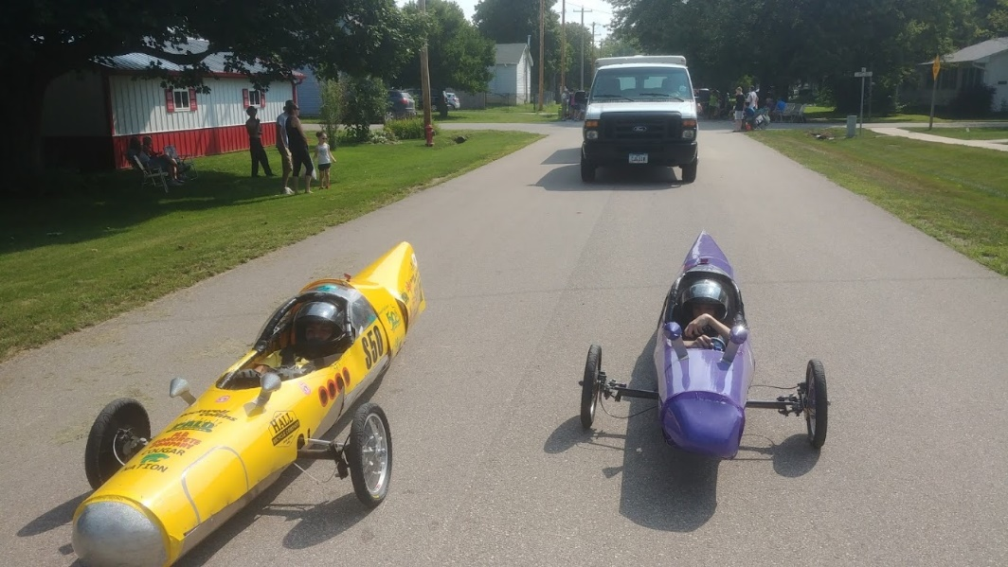
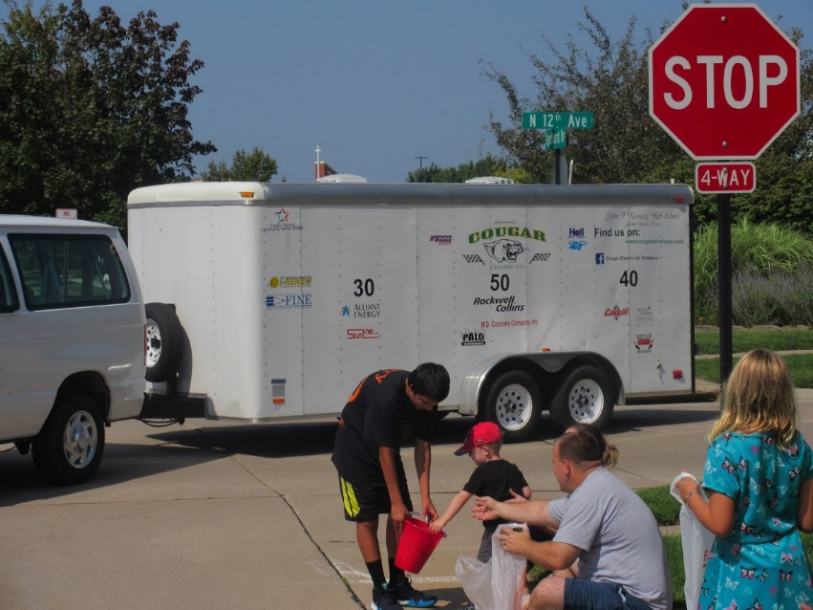

Fall Dinner
Our program's major fundraising and promotional event is our annual fall dinner. We spend about a week converting our school's shop into a restaurant, with a banquet of food in the front of the shop, and seating for around seventy-five people in the back. Putting on the event is a full team effort; all students in the program participate in setup, distribution of the food, or clean up. Past crew chief Derek worked the dessert table while documentation writers Elizabeth and Kaleigh, as well as current crew chief Jakob Davis scooped food and helped announce and pass out door prizes. We were very lucky to have a multitude of sponsors who donate door prizes to our dinner, which we handed out to our guests after they were done eating. Our fall dinner serves as a team bonding event, a sponsor recognition and appreciation night, as well as a way to get the families of our students involved in the program. Sponsors also attended this event to see how the money they donate is used as we have all cars on display. One of our sponsors that attended was Longhorn Enterprises, who are pictured below with their door prize donation. The connection between the parents, our sponsors, the students, and our advisor is of utmost importance to keep the program running. Through this event, we raised seven hundred dollars in meal sales, gained two sponsorships, and had dozens of t-shirt and hoodie orders placed. Our last team dinner was held on October 26th, 2019.
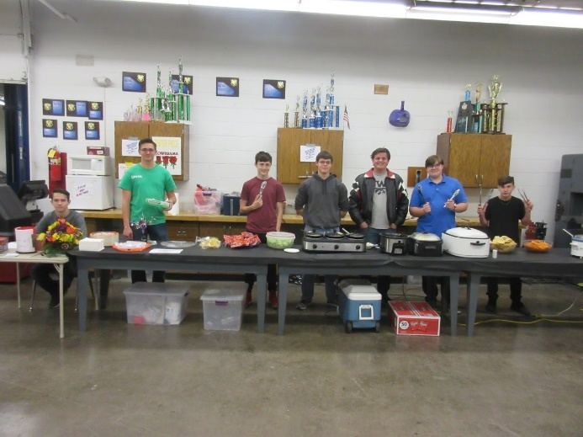
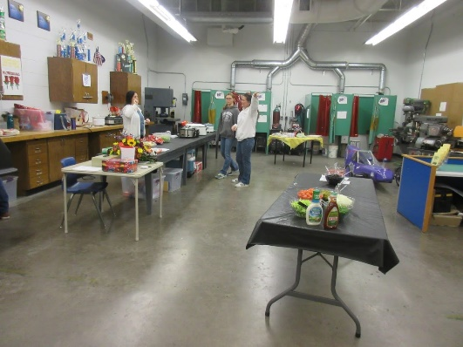

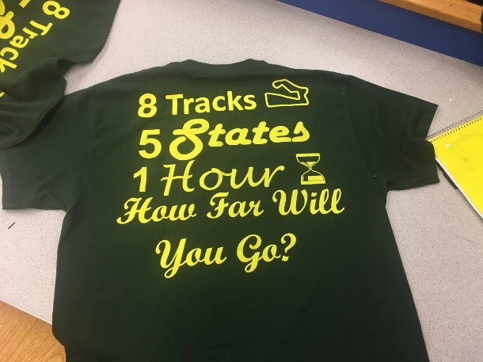

Hawkeye Downs
Every year our full electric car program hosts the Midwest speed trials at Hawkeye Downs in Cedar Rapids. The entry fees for every car are used to fund the event itself, however, the concessions stand is a fundraiser for our program. Since we are also racing our cars in the race, the 984’s car team was in the pits and on the track. In turn, the concession stand was being run by students apart of overall program teams like aerodynamics or graphics along with parents. Through concessions, we were able to raise around four hundred dollars.

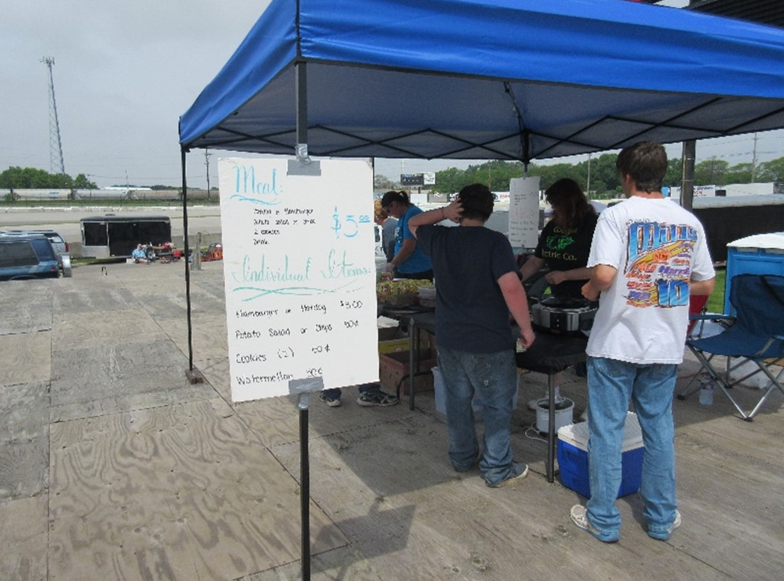

Kennedy Club Fair
Each year our high school sponsors a club fair to help advertise all of the exciting clubs and activities a high schooler could be involved in. The electric car team utilizes this opportunity to advertise our club to the student body, and hopefully get a few interested individuals to join the team. The most recent club fair was held on September 16th, 2019 in Kennedy’s gymnasium. On the morning of the club fair, current crew chief Jakob helped haul the 984 car out of our shop and into the gymnasium, while the documentation department was busy setting up a display table that included our trophies from the prior season. Our team was able to pitch the program to many prospective team members and was able to gain two members from the ordeal. Driver Kaleigh Martin of the 984 also had a lot of fun driving slowly around the gym, surprising many students who had never seen our cars in action.

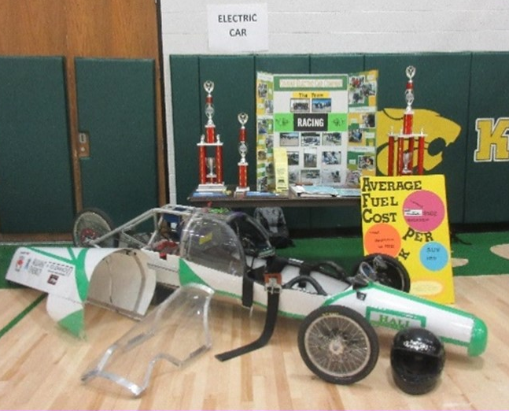
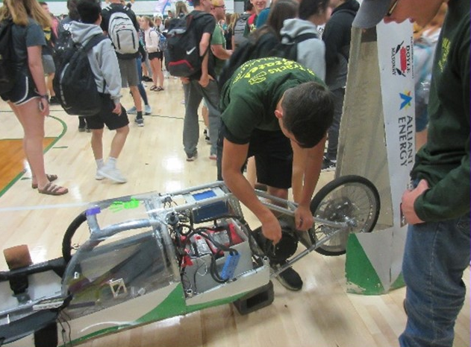
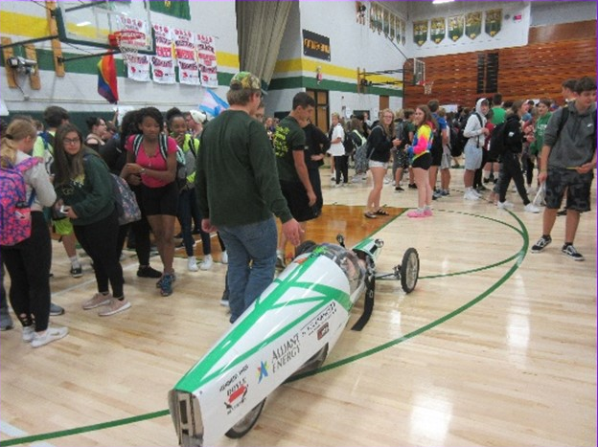

Open Minds Open Doors STEM Expo
Open Minds Open Doors is a STEM conference aimed at middle school aged girls. This conference allows our team to engage and interact with possible students and garner interest in the program in our community. Not only do we have the opportunity to interest incoming students to join our team, but we also gain exposure to local STEM companies who may be interested in sponsoring us. This year we attended Open Minds Open Doors on October 8th, 2019, at Coe College. Our representatives included the 984 driver Kaleigh Martin, 985 driver Elizabeth Severson, and battery team lead Noah Wilson. We took part in the STEM Expo in the Coe College gymnasium, where various companies and colleges gathered to share their work in the STEM field. We showed off the 984 car at the Expo, allowing any willing participant to put on a helmet and sit within the car while explaining the STEM opportunities within our program including mechanical engineering, the engineering behind the design of the cars, programming within the telemetry department, and the electrical engineering knowledge that can be gained while participating in our electrical department.

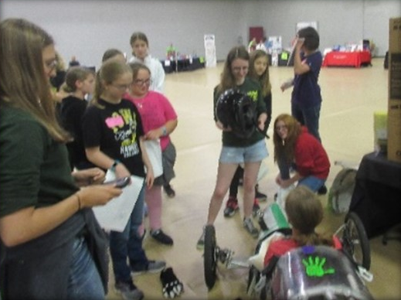
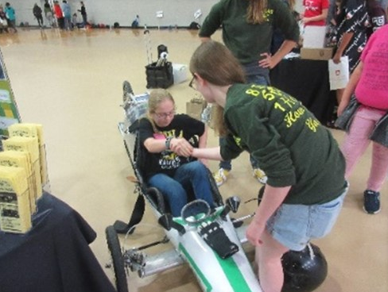
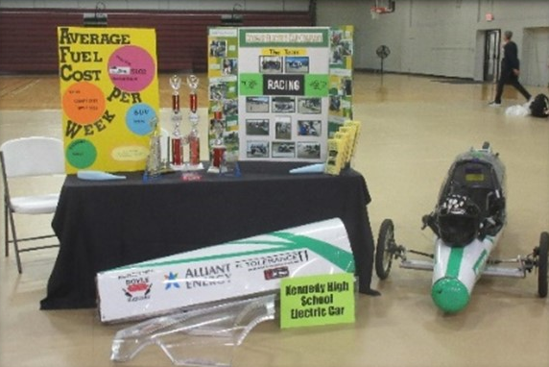

Kennedy Class of 2024 Incoming Freshmen Orientation
Every year Kennedy High School hosts an “Incoming Freshmen Night” for students who are currently in eighth grade and their parent to explore different classes and activities they could take or do during their high school career. This event runs in fifteen-minute ‘classes’ with five-minute passing times. Even though electric car at Kennedy is a regular class offered during the school-day, we do not host a ‘class’ during this event. Instead, we set up in the school’s main foyer at the entrance with other the activities for parents and student to see as they come on or during the passing times. We used the old 983 as our display car for this event as this event is held in the middle of our construction season and no current car was ‘display ready’; also a part of our display was our normal trophy and trifold set-up we use at most expos and open houses. The program was being represented by crew chief Colin Flannagan at this event. Throughout the night he answered student’s and parent’s questions, mainly regarding the program’s status as both a class and an extracurricular. His pitch seemed to be very successful as we had four students tell us they were going to sign up for the class next year. The program also enjoyed a visit from the Chinese lion dance club.

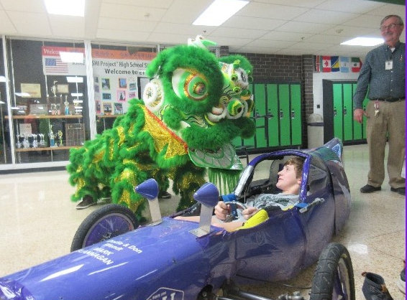
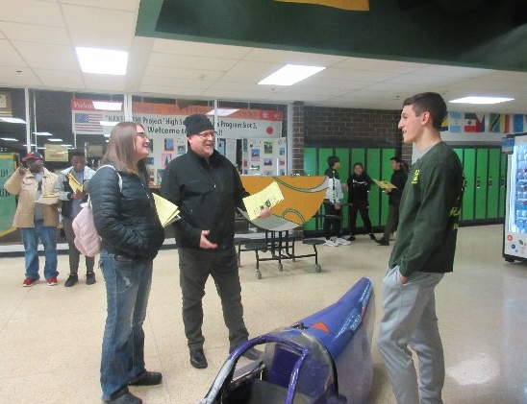

Kennedy Fall Open House
The annual Kennedy Fall Open House is an opportunity parents, students, and future students to learn about programs and activities within our school and community with a focus on STEM and the trades. This is a very useful recruitment and sponsorship outreach event. The open house is held very early in the school year meaning it is within our school’s ‘grace period’ for rearranging schedules and dropping class. This makes it possible for students who hadn’t known about our program prior to join the class for the first semester. This is preferable as having too much time between when a student decided they want to join the class and when they have an opportunity to sign up for it they can lead to the student forgetting what exactly the program is and lose interest. On the sponsor requisition side, this event is attended by a lot of local construction and electrician companies looking to interest students in perusing a trade after high school. Companies like this have sponsored us in the past and this is a great opportunity for us to talk to them about our program and for them to see our display. Most sponsors don’t have the opportunity to see our cars in person and talk to us face to face since a lot of communication with sponsors is over the phone or through e-mail. At this event the 984’s team was being represented by crew chief Jakob Davis and driver Kaleigh Martin as well as many members of our electrical engineering team. They were able to talk to both prospective members and sponsors and had a lot of fun showing off our cars.
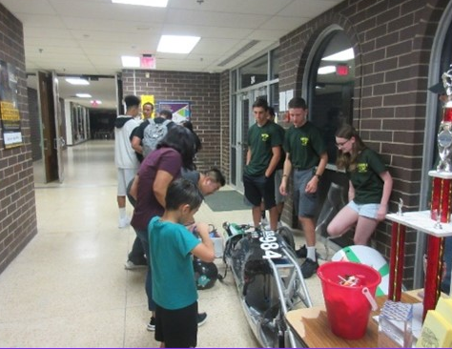
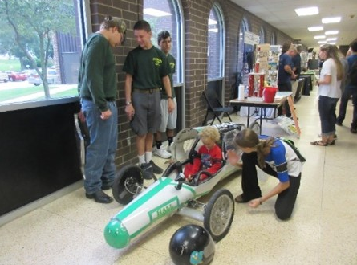

ADD 983 MASTER FUNDRAISING SECTION
sponors

