Kennedy High School
Advisor: Barry Wilson
Location: 4545 Wenig Rd. NE, Cedar Rapids, IA, 52402
Phone Number: 319-784-7697
bwilson@cr.k12.ia.us
Bryan Becker, Grade 12, Crew Chief
Isaac Hofferber, Grade 9, Assistant Crew Chief
Elizabeth Severson, Grade 10 Driver
Rodrigo Sagastume, Grade 11, Driver
Kaleigh Martin, Grade 10, Documentation writer

985/A985 February Monthly Report
Bryan Becker, the 985 car’s crew chief, and his assistant crew chief, Isaac Hofferber, have made several changes to the car to improve both performance and design. The two major performance-increasing modifications are the introduction of a new axle and a new rear design.
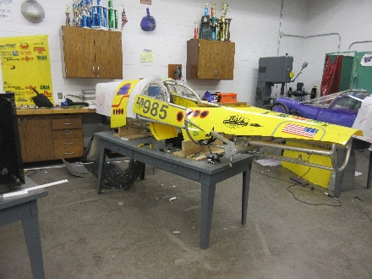
First was the introduction of a new axle. The previous axle was a solid steel bar stretching nearly 3 feet in length. Due to the weight of steel, the team has elected to use a lighter, aircraft grade, aluminum airplane strut. This 6-foot strut was shipped from Florida in early December and was quickly cut in half to be used on the car. Plates were added to the strut’s middle for mounting to the car and on the ends for mounting knuckles. This design simplifies the mounting system and is around 7 pounds lighter than the previous design.
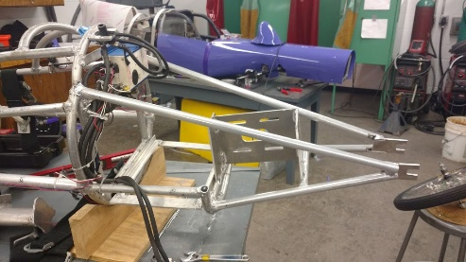
The second of the two changes made was the complete remodel of the rear of the car. This process was started in late November and finished late February. The problem with the old swing arm that held the rear wheel was that it was heavy and featured an ineffective shock absorber. The angle at which it was mounted led to little room for the wheel to move, rendering the suspension useless. Instead of trying to make a better suspension system, Bryan decided to abandon the suspension altogether. The new rear features four straight bars connecting the wheel to the rest of the car making a much simpler and lighter design. Due to the new shape, a new tail also needed to be constructed. The old design included two separate pieces that allowed access to the batteries and gearing. For better aerodynamics, weight, and overall simplicity, a one-piece cover was constructed. The new tail end of the car was finished after a day of work in the shop in late February.
The 985 as of Mar 1st.
The finished framing of the new tail design
The graphics team has made our shirt design for the year and is getting ready to mass-produce them over the coming weeks. Rodrigo Sagastume, our graphics person, also took time to make the 983’s number board at short notice for our Incoming Freshman Orientation. Orientation went well, and we think we have recruited several new members for the upcoming 2020 season.
The batteries team has successfully set up the dyno tester and is running battery tests on our old A and B battery sets to see how well the batteries would perform in the upcoming racing season.

