Kennedy High School
Advisor: Barry Wilson
Location: 4545 Wenig Rd. NE, Cedar Rapids, IA, 52402
Phone Number: 319-784-7697
bwilson@cr.k12.ia.us
Bryan Becker, Grade 12, Crew Chief
Isaac Hofferber, Grade 9, Assistant Crew Chief
Elizabeth Severson, Grade 10 Driver
Rodrigo Sagastume, Grade 11, Driver
Kaleigh Martin, Grade 10, Documentation writer
985/A985 (50 car) March Monthly Report
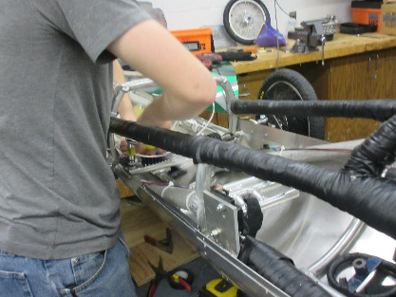
This month, a lot of progress has been made on the 50 car. Bryan Becker, the crew chief, and his assistant, Isaac Hofferber, have finished the car’s skeleton, and they have also attached the belly pan and plastic exterior. He has also applied the foam padding on all the bars. He and his driver, Rodrigo Sagastume (who just happens to be our graphics lead), worked very hard to make a newer, flashier, exterior. It is a dark grey background, with forest and lime green stripes in a geometric pattern, that is sure to make the car stick out.
The Batteries team has completed their tests on our battery sets and are working on two things; preparing the trailer for race season and matching up the best possible arrangements for the “B” sets and the setups. The place we used to buy our Optima batteries at has stopped selling them, but we are now buying them from Advanced Auto.
The telemetry team has almost perfected the system, and only has a couple bugs and kinks to work out. After they finish, they will be taking apart our dyno mule, and returning the various elements to storage.
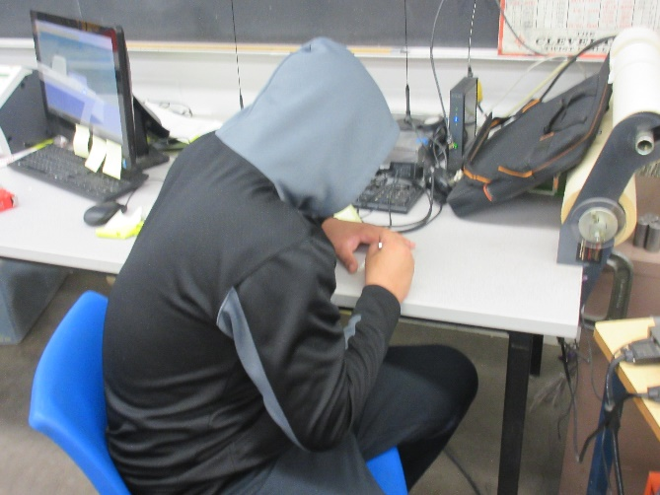
The graphics department has been working constantly to produce the necessary number boards for the first race in Nebraska on April 6th and has also been racing to finish the team shirts.
Our documentation crew has been working beyond overtime to get the books done by the first race but are going to make it with a lot of extra work.

