Kennedy High School
Advisor: Barry Wilson
Location: 4545 Wenig Rd. NE, Cedar Rapids, IA, 52402
Phone Number: 319-784-7697
bwilson@cr.k12.ia.us
John Tedesco, Grade 11, Crew Chief/ Driver
Collin Flannagan, Grade 9 Assistant Crew Chief
Brian Stubblefield, Grade 9 Documentation Writer
983/A983 (30 car) April Monthly Report
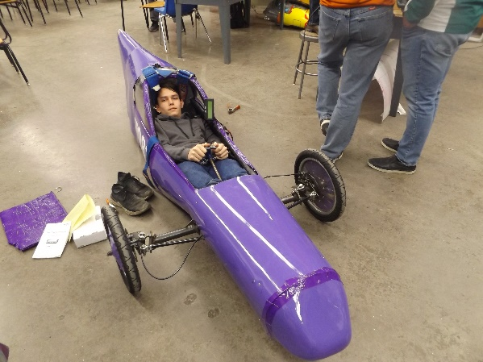
This month the work done on the 30 car was mainly limited to minor fixes and adjustments found during races. It has been mostly inspections and tests to ensure the car is going to be at it’s best for the race at the end of the month. We have also experimented with a new canopy.
The team has been very successful this season. At our first race in Hastings, NE, Rodrigo Sagastume got first place Endurance in the (A)985 and John Tedesco got second place Endurance in the (A)983. At the next one in Platteville, WI, Kaleigh Martin got first place Endurance in the (A)983 and Elizabeth Severson got second place Endurance in the (A)985. This was both driver’s first race.
The documentation team has been working overtime to finish the books for Wisconsin, as well as figure out the multimedia from scratch.

