Prospectus

For

Cougar Electric Company

2018-19

- What We’re About

- Accomplishments in the 2018-19 Year

- Goals for 2018-19 Year

- Budget Plans for the 2018-19 Year

- Our 2018-19 Partners and Sponsors

- 2018-19 Budget Estimate

- What You Will Receive for your Support

- How to Contact Us

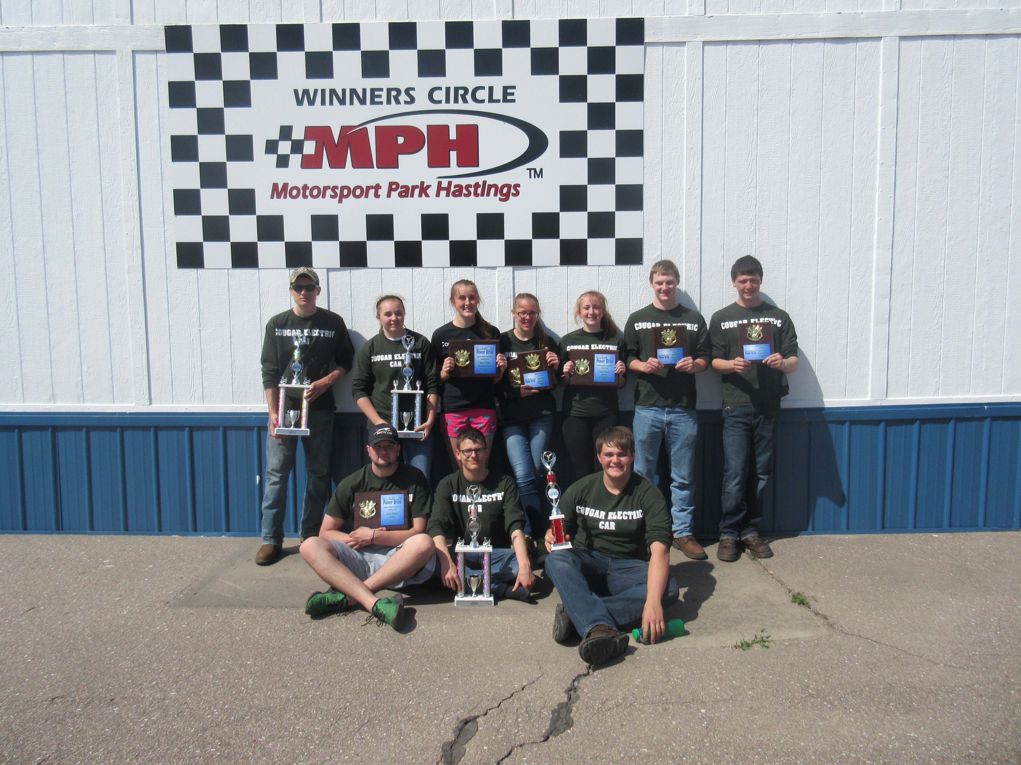

What We Are All About

Cougar Electric Company is not like most classes offered at the high school level. We have made it our mission to simulate a real-world company.

Students face high-level challenges every day they walk into the classroom. They deal with different types of learning expectations in the field they choose to explore. Our engineers – electrical, chemical, and mechanical - deal with challenges that are so unique sometimes professionals can not offer advice and they have to find their own answers. In their commitment to electric car, all students do their best to further their education by facing challenges that no other high school course can offer.

The company is divided into different teams: promotion, publicity, graphics, mechanical engineering, telemetry, aerodynamic engineering, and electrical engineering. Our teams work with area business professionals and staff who give their time, advice, and most importantly, teach students how to deal with real-world problems.
We hope that after reading about our class you will become as excited as we are to offer this alternative to traditional education. We need your help in order to continue this high level of learning.

Accomplishments in the 2018 Year

This year marked Cougar Electric Car’s twenty-first year.

Cougar Electric Company continues to participate in many events. This year we attended events in Wisconsin, Michigan, Iowa, and Nebraska. Below is the list of 2019 competition events that we had the opportunity, the ones bolded are the ones we plan to attend.

DATE | EVENT | LOCATION
April 6th | West Point | West Point, Nebraska
April, 12th & 13th | University of Wisconsin Platteville | Platteville, Wisconsin
April, 13th | Lincoln | Lincoln, Nebraska
April 26th & 27th | Stout/Hastings | Stout, Wisconsin/ Hasting Nebraska
April 28th &29th | Autobahn | Joliet, Illinois
May 4th | Wayne | Wayne, Nebraska
May 10th | Berlin | Marne, Michigan
May 13th & 14th | Road America | Elkhart, Wisconsin
May 18th | Hawkeye Downs | Cedar Rapids, Iowa
May 19th | Prairie | Cedar Rapids, Iowa

Promotional Events that Cougar Electric attended in 2018 included: Cedar Rapids Freedom Festival Parade, Marion Fly-in Breakfast, Hiawatha Fun Fest Parade, Open Mind Open Doors Exposition, as well as Kennedy’s Homecoming Parade, and the Kennedy Open House.

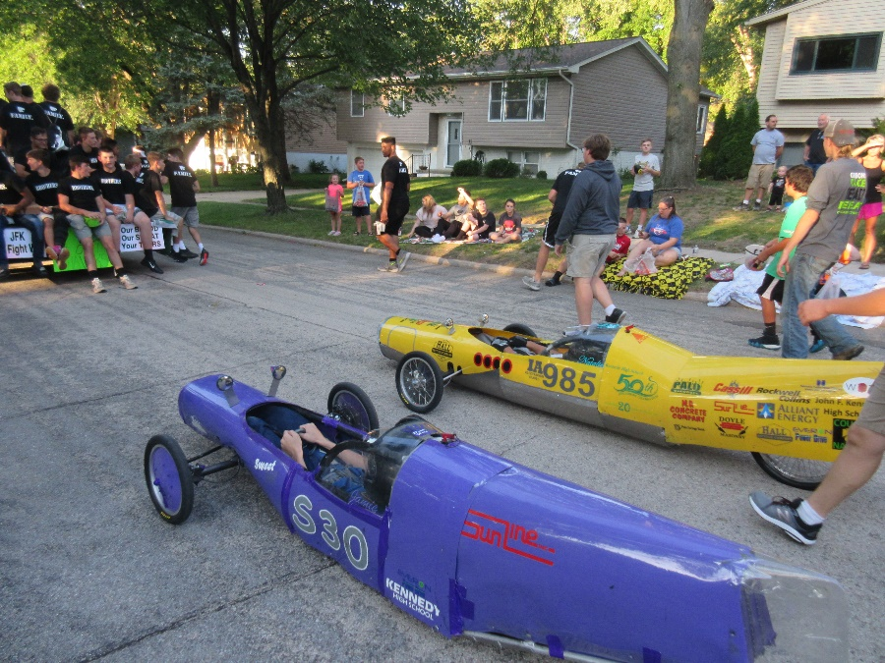

Goals for 2018-19 Year

In order to be successful in competition, a team must not only create a car which can go the greatest distance in an hour, but it must also do well at the other components of the competition – maneuverability, braking, design, and documentation.

- Promote alternative energy use
- Create three new cars, using new designs to become more efficient
- Make 1 major modifications our old car
- Race in Iowa, Michigan, Wisconsin and Nebraska competitions
- 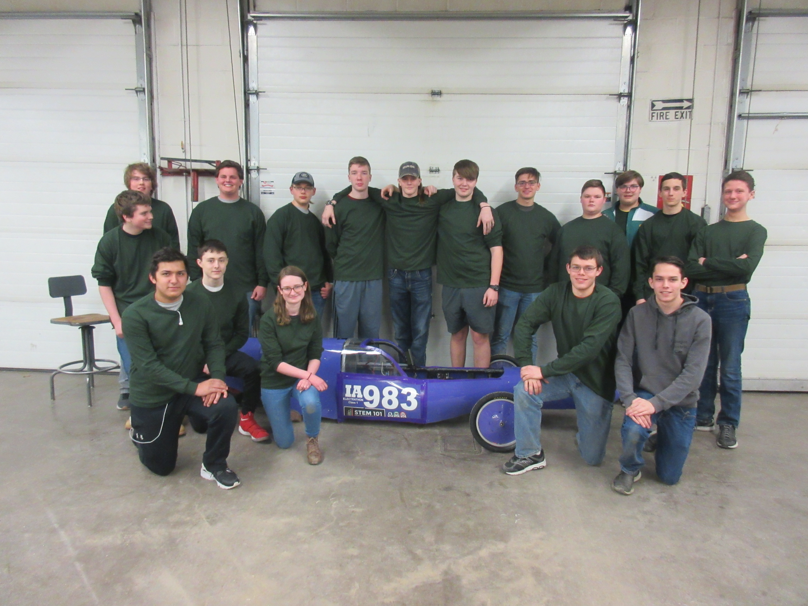Sponsor the Iowa competitions
- Participate in local community events

Partners and Sponsors
Cougar Electric Co. relies on sponsors and partners to realize its goals.

Partners offer money and advice for all facets of the company or competition events. Sponsors offer the money to build, compete, and promote the program.

Our 2019 partners and sponsors are listed below
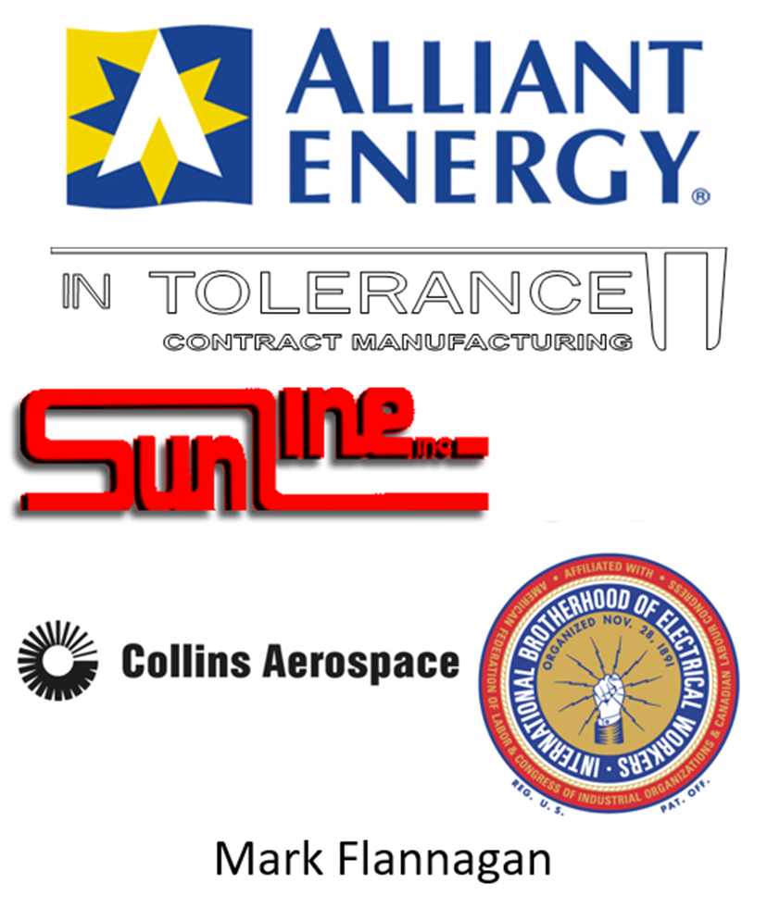

Cougar Electric Company
Budget Estimate
2018-2019
A. Cars $1,350.00
1. One new car
a. Chassis $400.00
b. Plastic Body $250.00
c. Painting Car $100.00
2. Update two cars
a. Chassis modifications $300.00
b. Body modifications $300.00

B. Batteries $1254.00
1. 6 New Optima ($209) $1,254.00

C. Telemetry $500.00
1. Parts for Telemetry research $500.00

D. Racing $6,290.00
1. Tires $540.00
2. Tubes $50.00
3. Fuel for Vans $3500.00
4. Misc. Supplies for Hauler & Cars $700.00
5. Motels $1500.00
a. Stout, Autobahn, Road Am (3 nights)

E. Speed Trials $1400.00
1. Trophies $300.00
2. Track Rental, Tickets, Power $500.00
3. Ambulance $600.00

F. Graphics $750.00

G. Promotion $1837.00
1. Sponsor Appreciation $382.00
2. Memberships
a. Michigan $180.00
b. Wisconsin $1050.00
c. Electrathon America $75.00
3. Miscellaneous $150.00
H. Misc. Shop Supplies $1,200.00

Total $14,581.00

Budget Plans for the 2018-19 Year

As of now we are still looking to find a new towing van. The van we have now is becoming less reliable. We are looking to put $5,000 more than our annual budget away to go towards a replacement.

Kennedy continues to be the sponsoring organization for electric car competition in Iowa. Since then we have been solely sponsoring the challenge, and we are looking for an outside sponsor to take over.

There seems to be a somewhat stronger focus on technical education in surrounding states. Cougar Electric continues to look at additional traveling to surrounding states, especially Nebraska, Michigan, and Illinois.
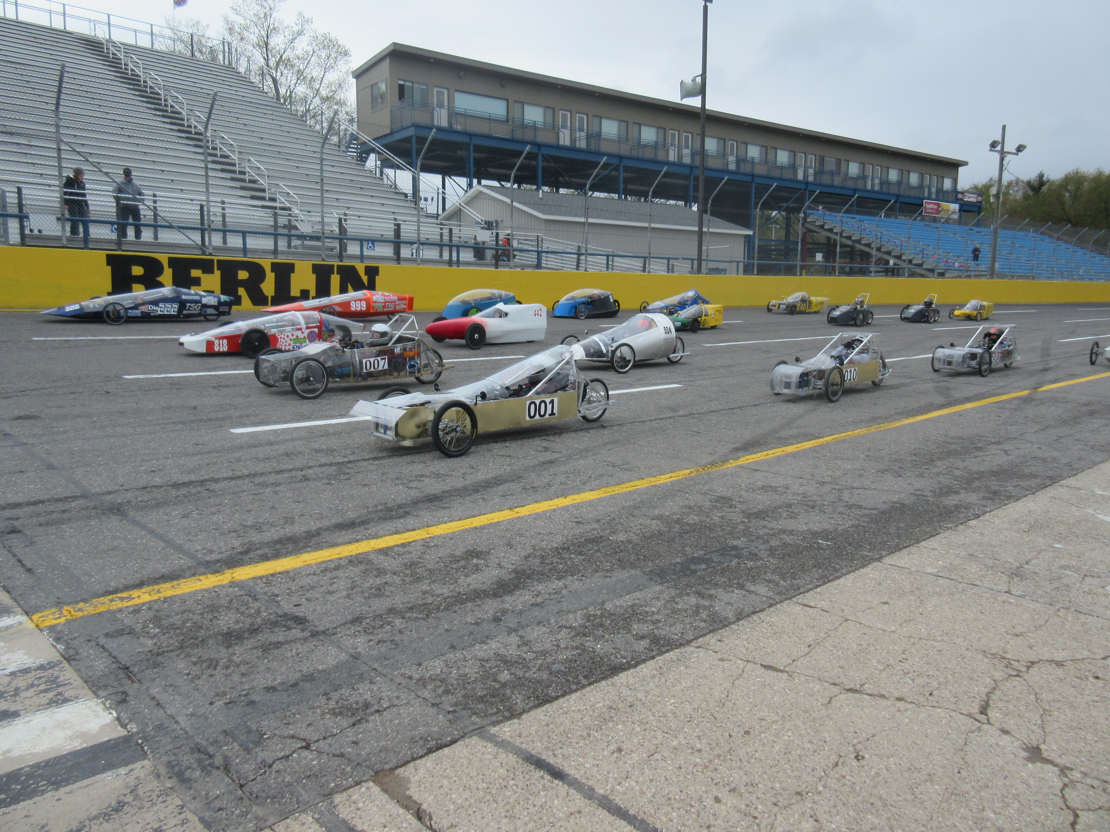

We Need Your Interest

Work has already begun for 2018. We are in the midst of ….

Attending several fall shows and educational activities
Designing a new 2019 car
Planning changes on two existing cars
Planning the Iowa program
Planning to use both the wind tunnel and chassis dyno in design

These are lofty goals and they will cost money. We enjoy seeing you become part of this learning process. We hope you consider becoming a sponsor or partner when contacted by our promotion team. A financial plan for the year is included with this prospectus. We accept any size donation. Sponsor dollars are the only way that the goals that we have can be reached. It is also tax deductible!

What You Will Receive for Your Support
Sponsors receive logo recognition on primary areas of race cars. Partners are also recognized on each car on the sides of the nose (the middle of each side is reserved for the number of the car). Your company's logo will be prominently displayed on both sides of the trailer as the sponsor of the chosen car. A strong effort is made to have the car and trailer out in public regularly; our goal is to have more than 50,000 people see the program each year. We accomplish this by attending six or more races throughout the Midwest. We attend competitions from April to October. We also attend all possible public festivals and parades in the Cedar Rapids area, including all public educational events in and related to Kennedy High School. We actively solicit opportunities to have the program highlighted in school and area media. We have been on TV and in the newspaper in the past and look to increase that exposure.
By supporting our company, you are making a difference in how students develop their knowledge of the world. It is hard to replicate a business-type atmosphere for students before they graduate. By participating in real-world education early, students are challenged in several personal development areas including teamwork (with students and adults), goal setting, problem solving, and skill development. They may even be introduced to their future career. Several graduates have gone on to careers similar to their involvement in Cougar Electric Company.
Thank you for your interest. Please give us a call or e-mail us if you have any questions or if you need any other information.
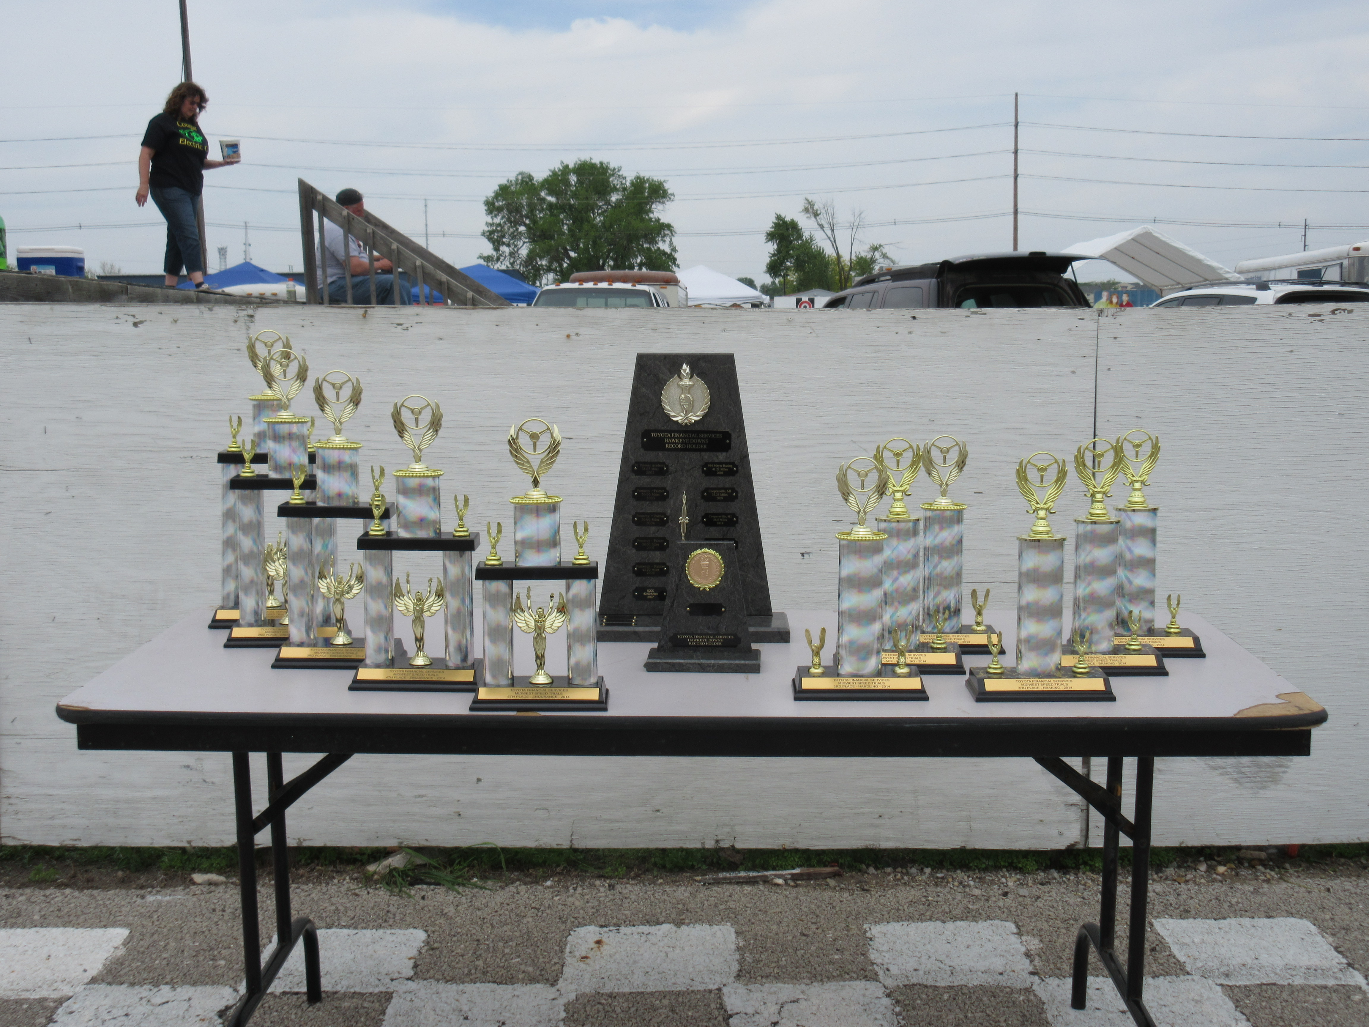

How to Contact Us
School: Kennedy High School
c/o Barry Wilson (Advisor)
4545 Wenig Rd. NE
Cedar Rapids, IA 52402
Phone: Barry Wilson (Advisor)
(319) 558-1595 (school number)
E-mail: bwilson@cr.k12.ia.us
Website: www.cougarelectriccar.com
Facebook: Kennedy Electric Car Company

